Engineering Design I Robot Competition Technical Report

Darren George, Joseph Pelligra & Emily Weeks

December 4th, 2017

E-121, Section U, Group 6

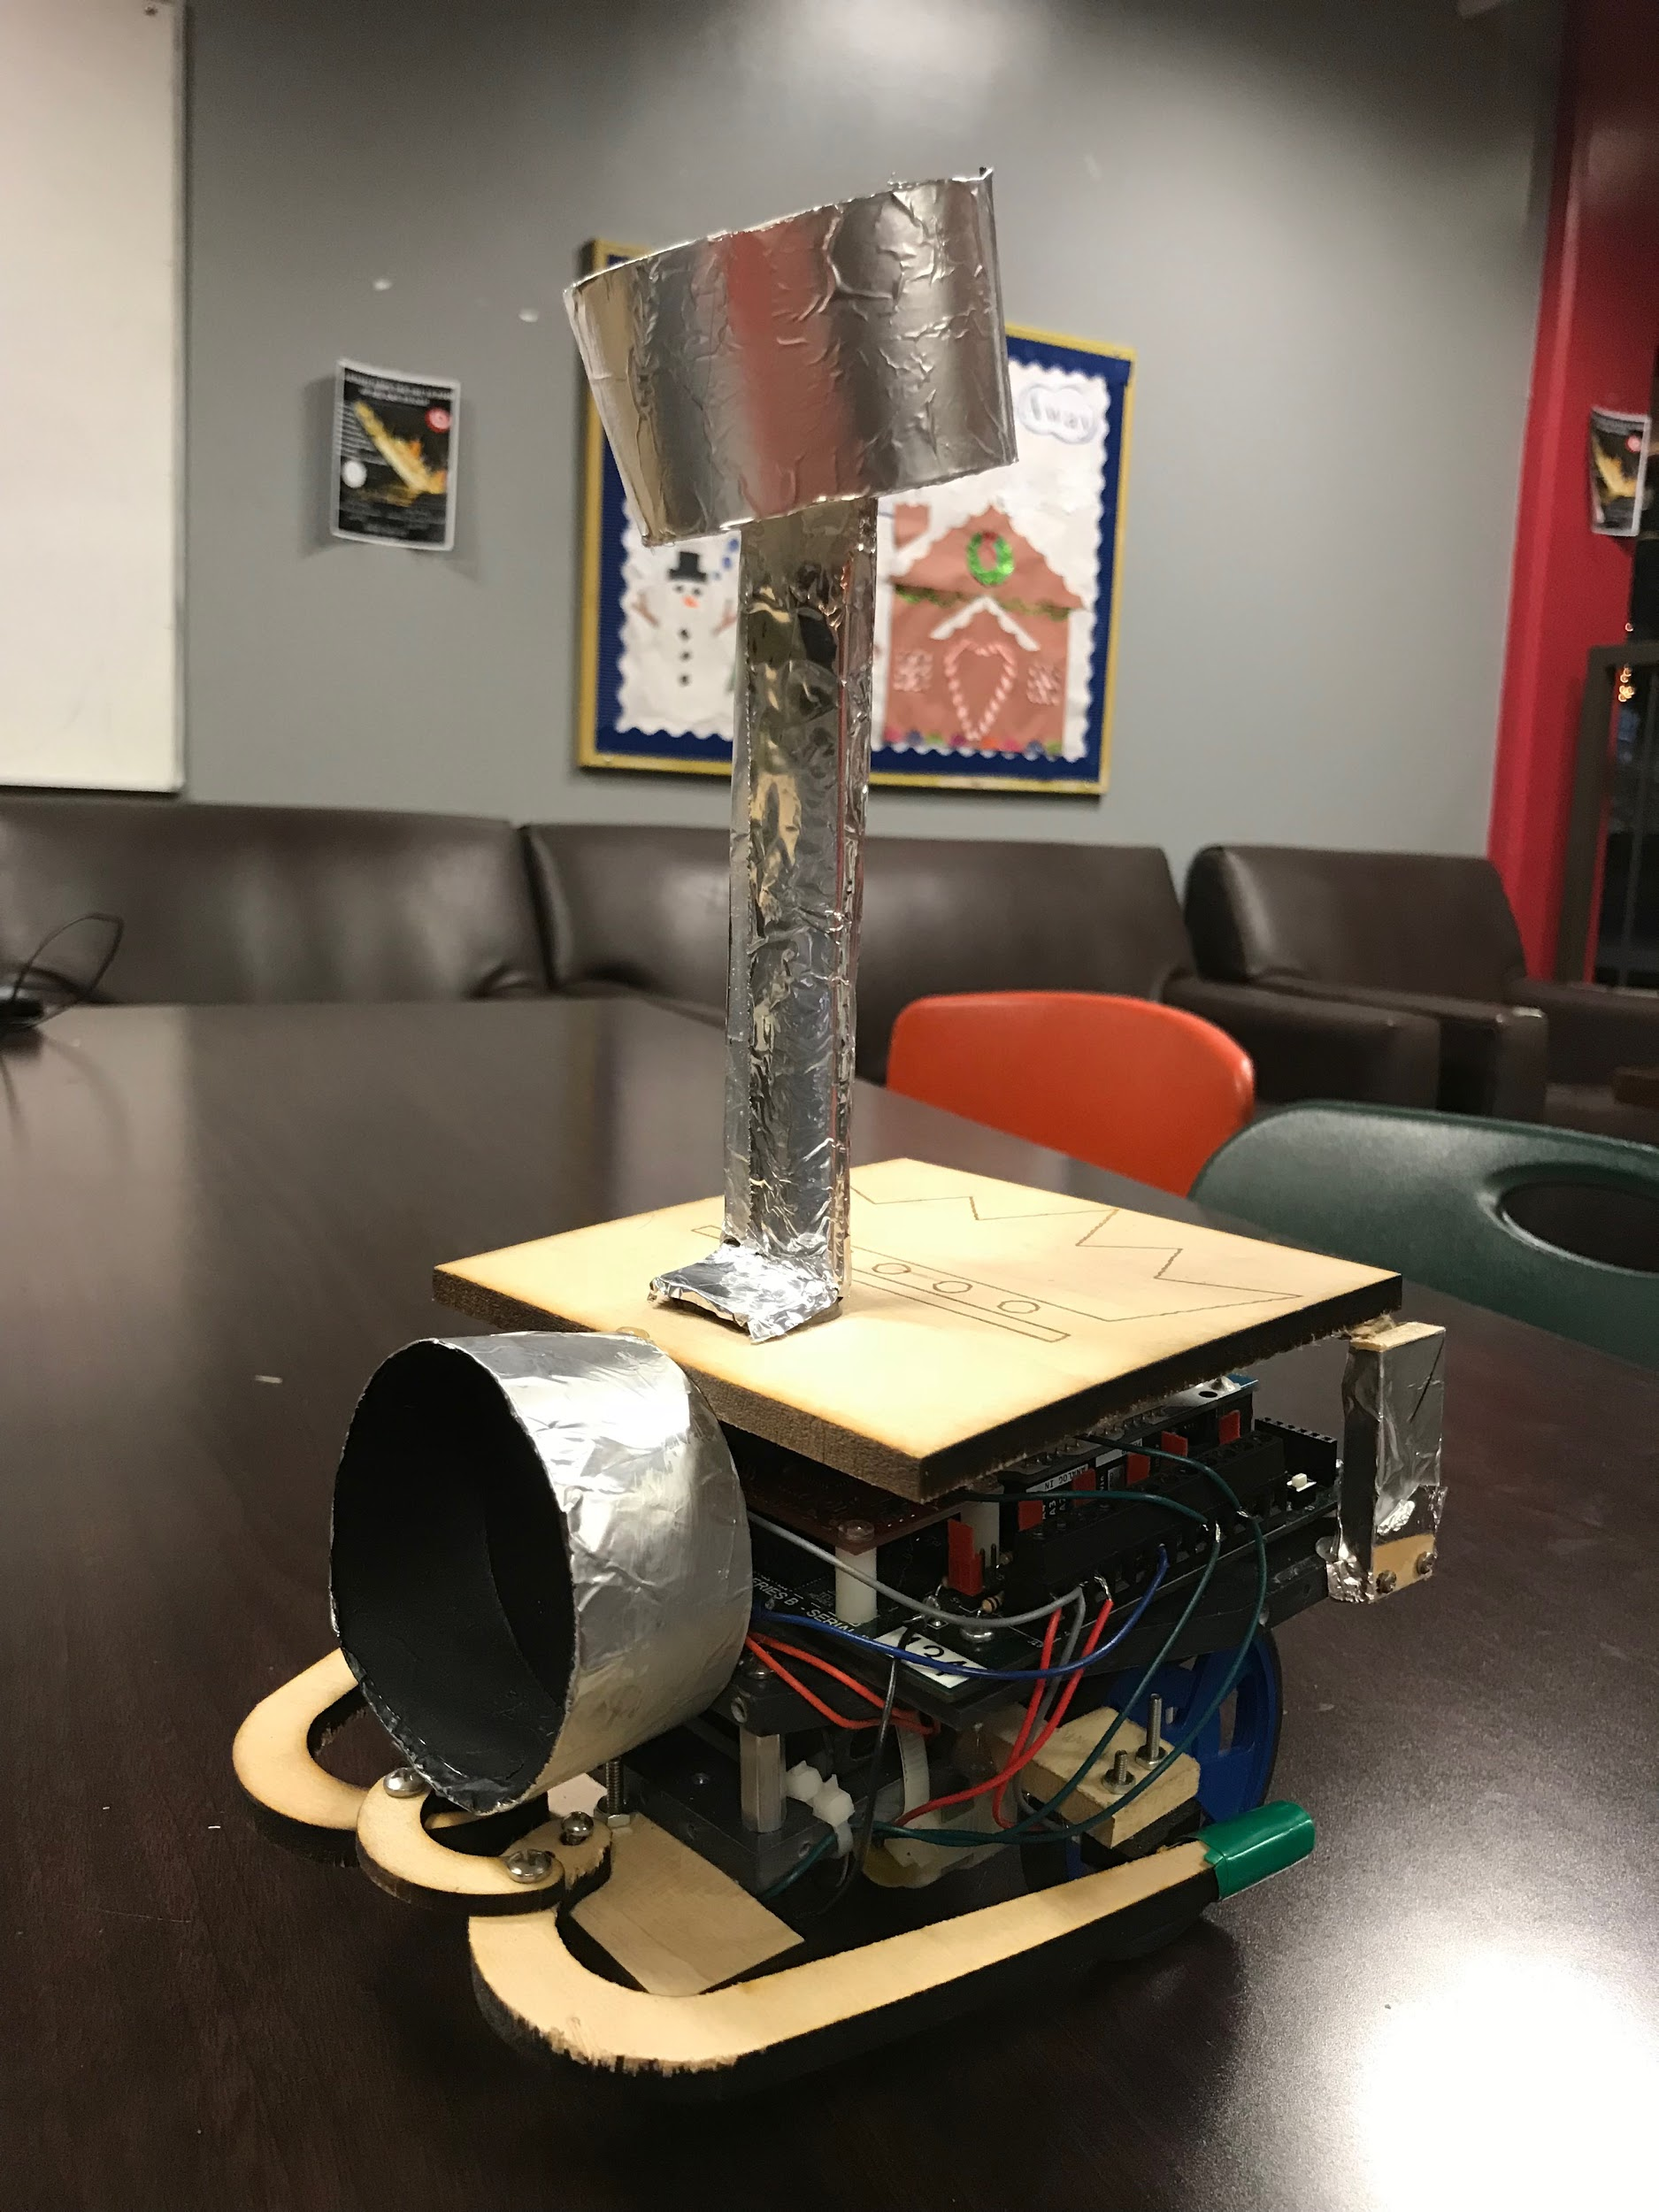

I pledge my honor that I have abided by the Stevens honor system.

* Emily Weeks 10420303
* Darren George 10428940
* Joseph Pelligra 10422942

Abstract

In this report the team will discuss how we accomplished the robot project. The robot will participate in a competition against other group robots to knock out target lights on the opposing team’s side before the enemy can knock out target light on our side. In this report we discuss how the team accomplished this project by efficiently organizing our work between the team, and how the mechanical, electrical and software components were solved. There were many different aspects of our robot that makes it unique in each of the three components that we go into in this report. In the end, we discuss how the team performed in the competition, and what we learning working on this project for the last 3 months.

Table of Contents

* Introduction pg.1
  + Purpose pg.1
  + Background pg.1
  + Planning pg.2
* Discussion pg.3
  + Requirements pg.3
  + System Design pg.3
  + Mechanical Design pg.5
    - Light Sensor and Floor Sensor Module Design pg.5
    - Bumper Design pg.7
    - Logo Design pg.11
  + Software Design and Coding pg.11
    - Software Requirements pg.12
    - Subroutines pg.12
    - Unique Features pg.15
    - Computer Interrupts pg.15
    - Software Flowcharts pg.15
  + Electrical and Wiring Design pg.17
  + Assembly pg.19
    - Problems/ Techniques pg.19
    - Materials pg.19
    - Tools pg.19
  + Integration Testing and Evaluation pg. 20
* Final Competition pg. 21
  + The Process and Grading pg. 21
  + Class Results pg. 21
* Conclusions & Recommendations pg. 22
* Tables
  + Table 1 - Bumper Design Pugh Matrix pg. 4
  + Table 2 - Light Sensor Pugh Matrix pg. 5
  + Table 3 - I/O Pins to Robot Functions pg. 5
* Figures
  + Figure 1.1 - Arena 1 pg. 1
  + Figure 1.2 - Arena 2 pg. 1
  + Figure 2.1 - Bumper Mount pg. 6
  + Figure 2.2 - Bumper Switch Attachment pg. 6
  + Figure 2.3 - Bumper Switch Mount to Chassis pg. 6
  + Figure 2.4 - Floor Sensor Module Mount pg. 6
  + Figure 2.5 - Casing Mount to Chassis pg. 7
  + Figure 2.6 - Inside Light Sensor Cups pg. 8
  + Figure 2.7 - Outside of Light Sensor Cups pg. 8
  + Figure 3.1 - Initial Sketches pg. 8
  + Figure 3.2 - Initial Prototype pg. 9
  + Figure 3.3 - Initial Prototype Problem (Zoomed In) pg. 9
  + Figure 3.4 - Secondary Prototype pg. 9
  + Figure 3.5 - Secondary Prototype Solidworks file pg. 9
  + Figure 3.6 - Bumper Switch Problem (Zoomed In) pg. 10
  + Figure 3.7 - Bumper Switch Problem Solved pg. 10
  + Figure 3.8 - Bumper Mount pg. 10
  + Figure 4.1 - Laser Printed Logo pg. 11
  + Figure 4.2 - Solidworks Logo Design pg. 11
  + Figure 5.1 - Serial Monitor Code Snippet pg. 12
  + Figure 5.2 - Home Territory Algorithm Code Snippet pg. 15
  + Figure 6.1 - Arduino Circuit Board pg. 17
  + Figure 6.2 - Photosensitive Resistor Voltage Divider Circuit pg. 17
  + Figure 6.3 to Figure 6.6 - Wiring Pictures pg. 18
* Attachments
  + Work Structure Breakdown pg. A1
  + Gantt Chart pg. A2
  + Final Program pg. A3-A6
  + Setup Loop Flowchart pg. A7
  + Bumper Interrupt Flowchart pg. A8
  + Loop Flowchart pg. A9

Introduction

Purpose

The purpose of this report is to describe how we tackled the robot project and why we used specific methods when designing the robot. The entire robot from the bumpers, to the placement of light sensors, to the code have a multitude of ways to be accomplished, and we hope to describe our thought process for each component of the robot in this report.   
 Background

To successfully construct the robot we needed an understanding of software, mechanical, and electrical components. The mechanical aspect we had to learn was soldering, wood cutting, and the use of solidworks to 3D cut and laser cut wood parts. The software used to program the robot is the Arduino Software (IDE), so we had to learn the basics of the software to program the robot. The electrical aspect we had to learn was how to use electrical wiring to connect sensors, resistors, transistors, and LED’s to the arduino board.

The objective of the robot is to detect enemy’s targets on the enemy’s side which has a different colored surface than your home side’s surface before the enemy robot “knocks off” the target sensors on your home side. The robot must find the two enemy targets (set in unknown locations in the enemy territory) with the help of a navigation light which is 30” above the center of the arena (Figure 1.1 and 1.2).

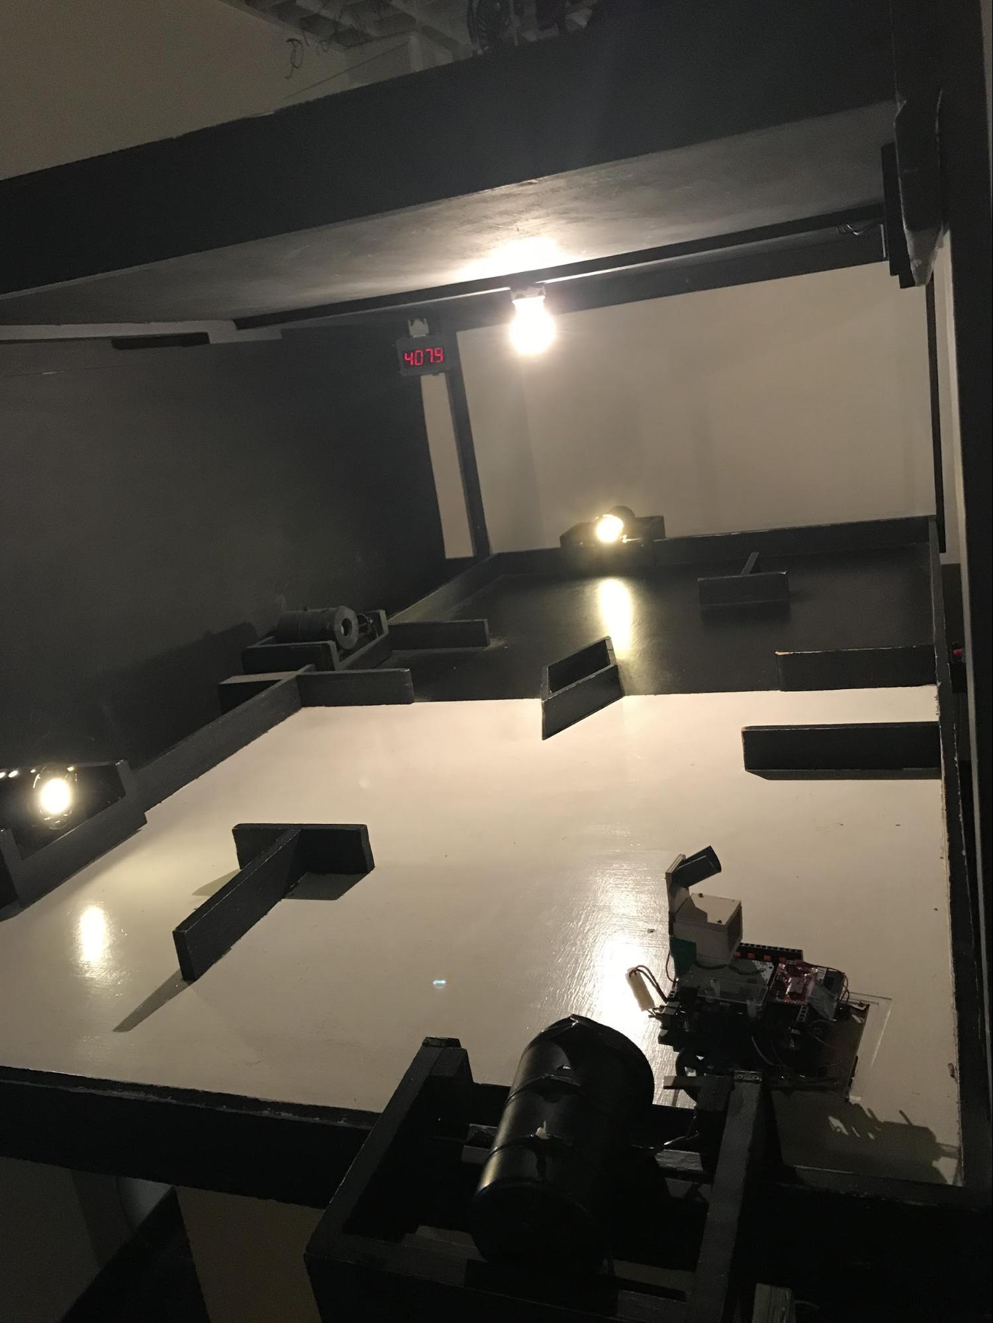 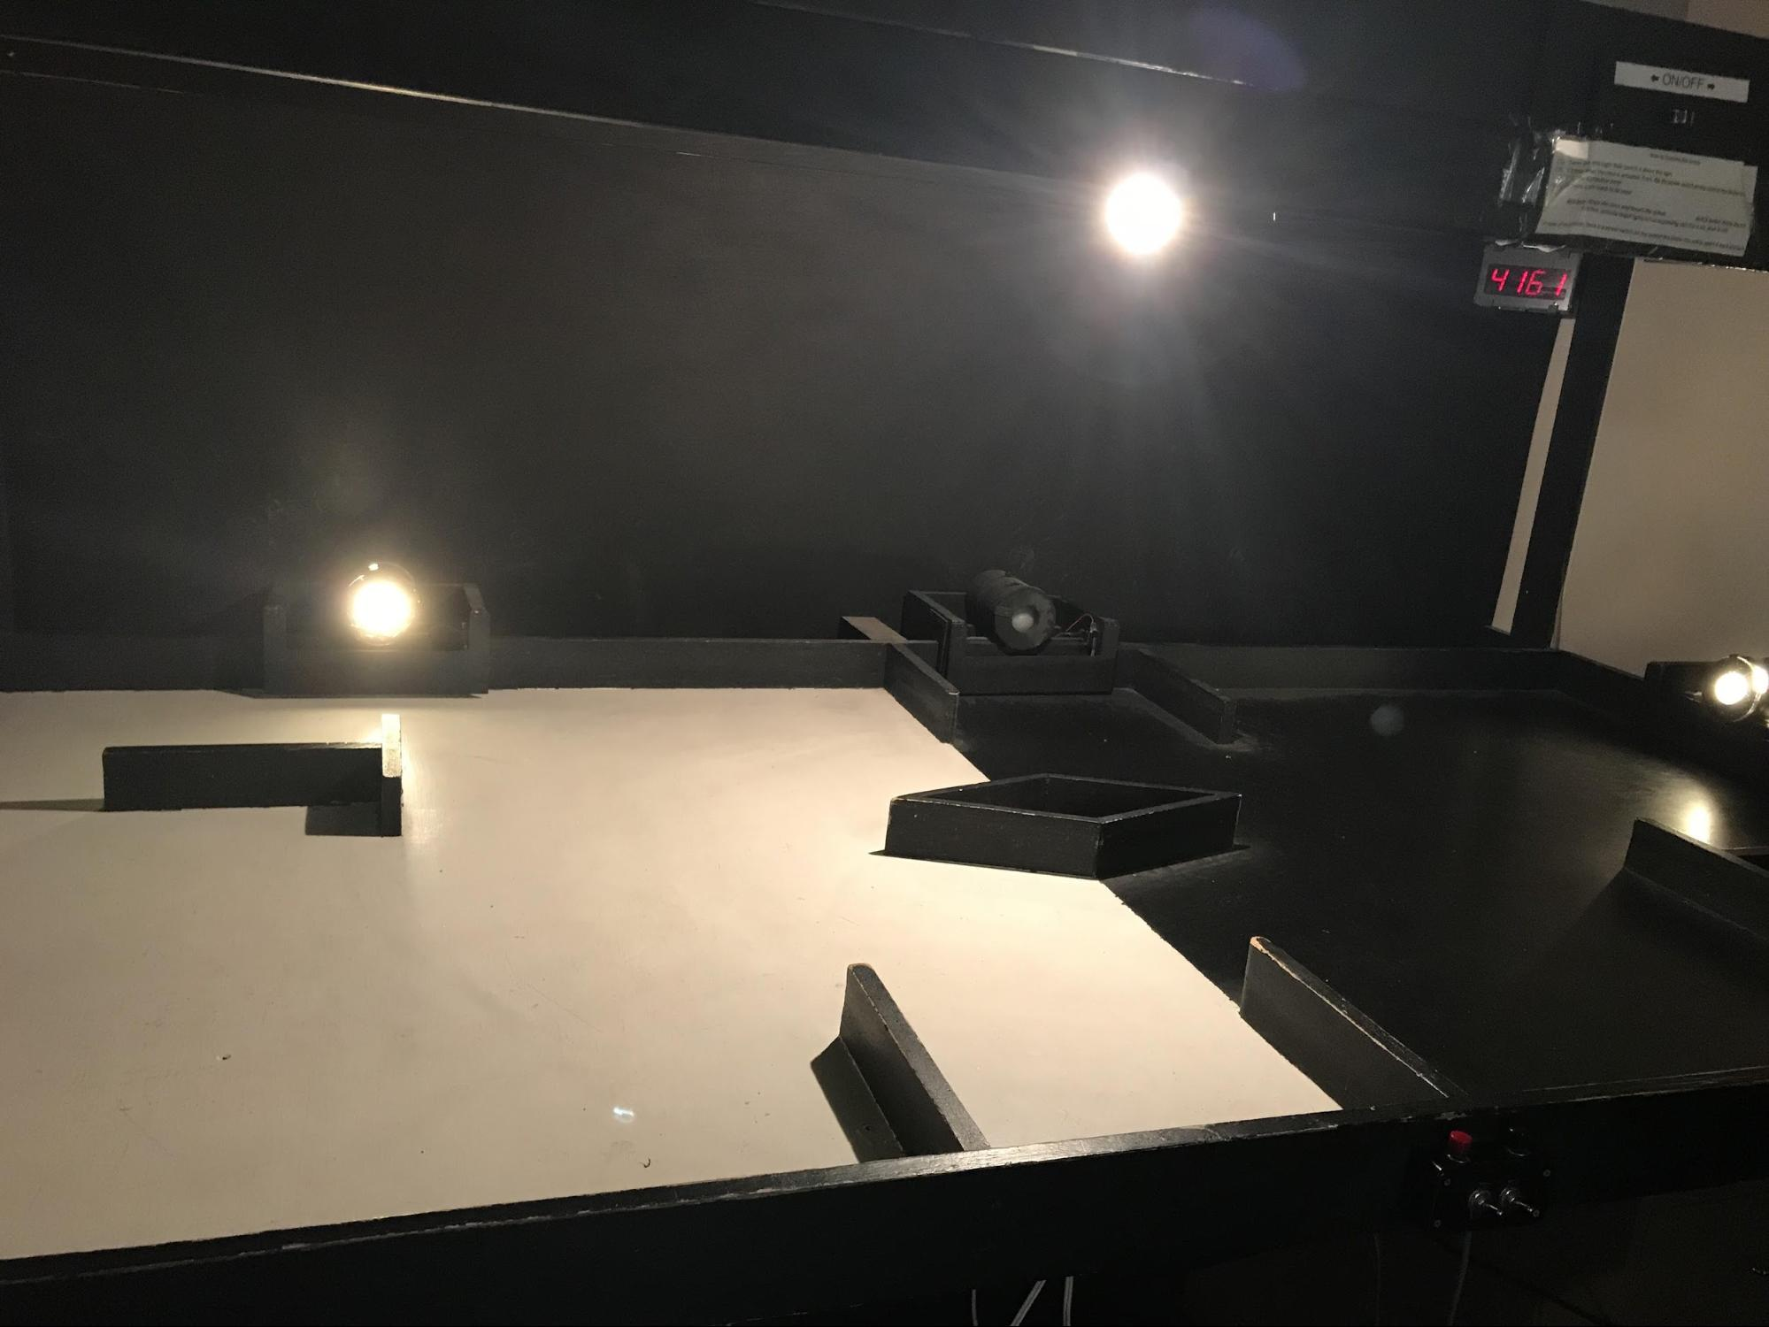

When the robot hits an obstacle, it must be able to use its bumpers to recognize when it has hit something, and the robot must be able to correct itself and continue with the objective. We will have to design our robot to know when it has crossed into enemy territory, and what to do after it has hit an obstacle. We also must design the robot to navigate through the court using the navigation light to cross into enemy court. Then the robot must detect the two enemy targets using light sensors to successfully “knock out” the targets and win the game.

Planning

The team worked together to create a comprehensive schedule for completion of the robot (See Gantt Chart pg. A2). Emily was in charge of organization and the mechanical design while Darren was in charge of documentation and electrical design and Joe was in charge of the program and software (See Work Structure Breakdown on pg. A1).

Discussion

Requirements

The first requirement the robot must complete is detecting which side of the arena it is on. This is accomplished by using the floor sensor module to pick up the light reading of the black side or the white side. The floor sensor module light stays on until the robot reaches the enemy side, then it tries to find the target lights, which is the second requirement. To find the target light, we used a light sensor to detect the two light sensors on the enemy side. The third requirement takes place throughout the journey of the robot competition, when the robot hits an obstacle. When the robot hits an obstacle it must change directions to continue with the competition. The Interrupt system worked by first putting the motors in reverse at 45% speed for 150 ms then turning to the right or left at 45% speed for an additional 150 ms depending on which bumper was hit. If both bumpers are hit the robot instead makes a larger turn due to a combination in the interrupt features. A three system bumper was created to detect if the robot was hit on the right bumper, left bumper, or both bumpers.

There were several rules/regulations that we had to abide by in the design of our robot. The team was not allowed to make any alterations to the two plastic mounting platforms, or the microprocessor board on the robot. This includes no drilling any holes, gluing items, or soldering on either of these parts of the robot. Also, no alterations to the wheels, gears, or battery pack are allowed. The battery pack cannot be supplied with extra power, so if one uses outside material that require power, it must use power from the battery pack. In addition, counter actions that would be destructive to your enemy are prohibited in the competition. Finally, the side of the arena you start on, and the positioning of the two light sensors on the enemy side are unknown to you during the competition, however, the layout of the arena (size, and obstacles) are known and will not be changed.

Some of the materials that were provided for us were cardboard for prototyping the bumpers, cardboard for the final design (navigation light tower), basswood, electrical wires, electrical tape, tool kit(ruler, screwdrivers, tweezers, pliers- wire cutting, and a safety knife), and a zip tie.

System Design

In the beginning stages of initial design the main requirement in the “win strategy” was efficiency. Using minimum materials for maximum impact was the goal. The team’s design consisted of 1 target light sensor and a 3 piece bumper system with 2 switches.

There were several ways the team aimed to minimize materials used. The platform was made with a simple wood made with a 3D cut, and we laser cut the logo on the platform instead of making the logo and attaching it on the robot. For the navigation light, a simple two piece cardboard “tower” was made with cuts in the middle to allow the light sensor to be placed high and angled upward. Finally, the wires were all made not to be loose so that the sensors were secured and the material used would be lowered.

We had one navigation light positioned over 6 inches above the platform, one target light in the front of the robot, floor sensor at the bottom rear of the robot, and two bumper switches on either side of the robot. By minimizing the amount of sensors and switches it allowed for the most material safed as well as being the simplest design which helps when writing the code.

A countermeasure that we wanted to instill was designing out robot with aluminum foil. We thought of this because it could act as a way to reflect light from the arena and possibly interfere with the enemy’s light sensor. This is a legal countermeasure according to the rules because it is not in any way destructive to the opposing team’s robot.

The software design is unique in the sense that it tries to use as little resources as possible. Only one light sensor is used to detect target Lights and there are only two bumper pins and interrupt features. The philosophy behind this decision is that it leaves less room for potential errors or failure.

Bumper Design Pugh Matrix (Table 1)

|  |  |  |  |
| --- | --- | --- | --- |
| Criteria | 1 piece bumper/ 1 bumper switch | 2 piece bumper/ 2 bumper switches | 3 piece bumper / 2 bumper switches |
| No weak spots | - | 0 | + |
| Durability | 0 | - | + |
| Feasibility | + | - | 0 |
| Efficiency | 0 | 0 | + |
| Sum of 0s | 2 | 2 | 1 |
| Sum of +s | 1 | 0 | 3 |
| Sum of -s | 1 | 2 | 0 |
| Net Score | 0 | -2 | 3 |
| Ranking | 2 | 3 | 1 |

Light Sensor Pugh Matrix (Table 2)

|  |  |  |  |
| --- | --- | --- | --- |
| Criteria | 1 Light Sensor | 2 Light Sensors | 3 Light Sensors |
| Accuracy | 0 | - | + |
| Fesability | + | 0 | - |
| Efficiency | + | 0 | - |
| Sum of 0s | 1 | 2 | 0 |
| Sum of +s | 2 | 0 | 1 |
| Sum of -s | 0 | 1 | 2 |
| Net Score | 2 | -1 | -1 |
| Ranking | 1 | 2 | 2 |

When brainstorming ways to counteract other robots the idea to use aluminium foil was brought up. Since the foil reflects light, it will affect the light sensor readings of other robots thus slowing down the robot.

I/O Pins to Robot Functions (Table 3)

|  |  |  |
| --- | --- | --- |
| Component | Pin | Wire Colors |
| Floor Sensor Module | D4 | White |
| Target Light | A4 | Blue |
| Navigation Light | A3 | Green |
| Bumper Switch #1 | D2 | Red |
| Bumper Switch #2 | D3 | Red |

Mechanical Design

When constructing the robot, a few aspects that were kept in mind were future accessibility, durability and efficiency. Ultimately zip ties, hot glue, screws, nuts, and bolts were used. The bumpers were mounted using screws, nuts and bolts (Figure 2.1).

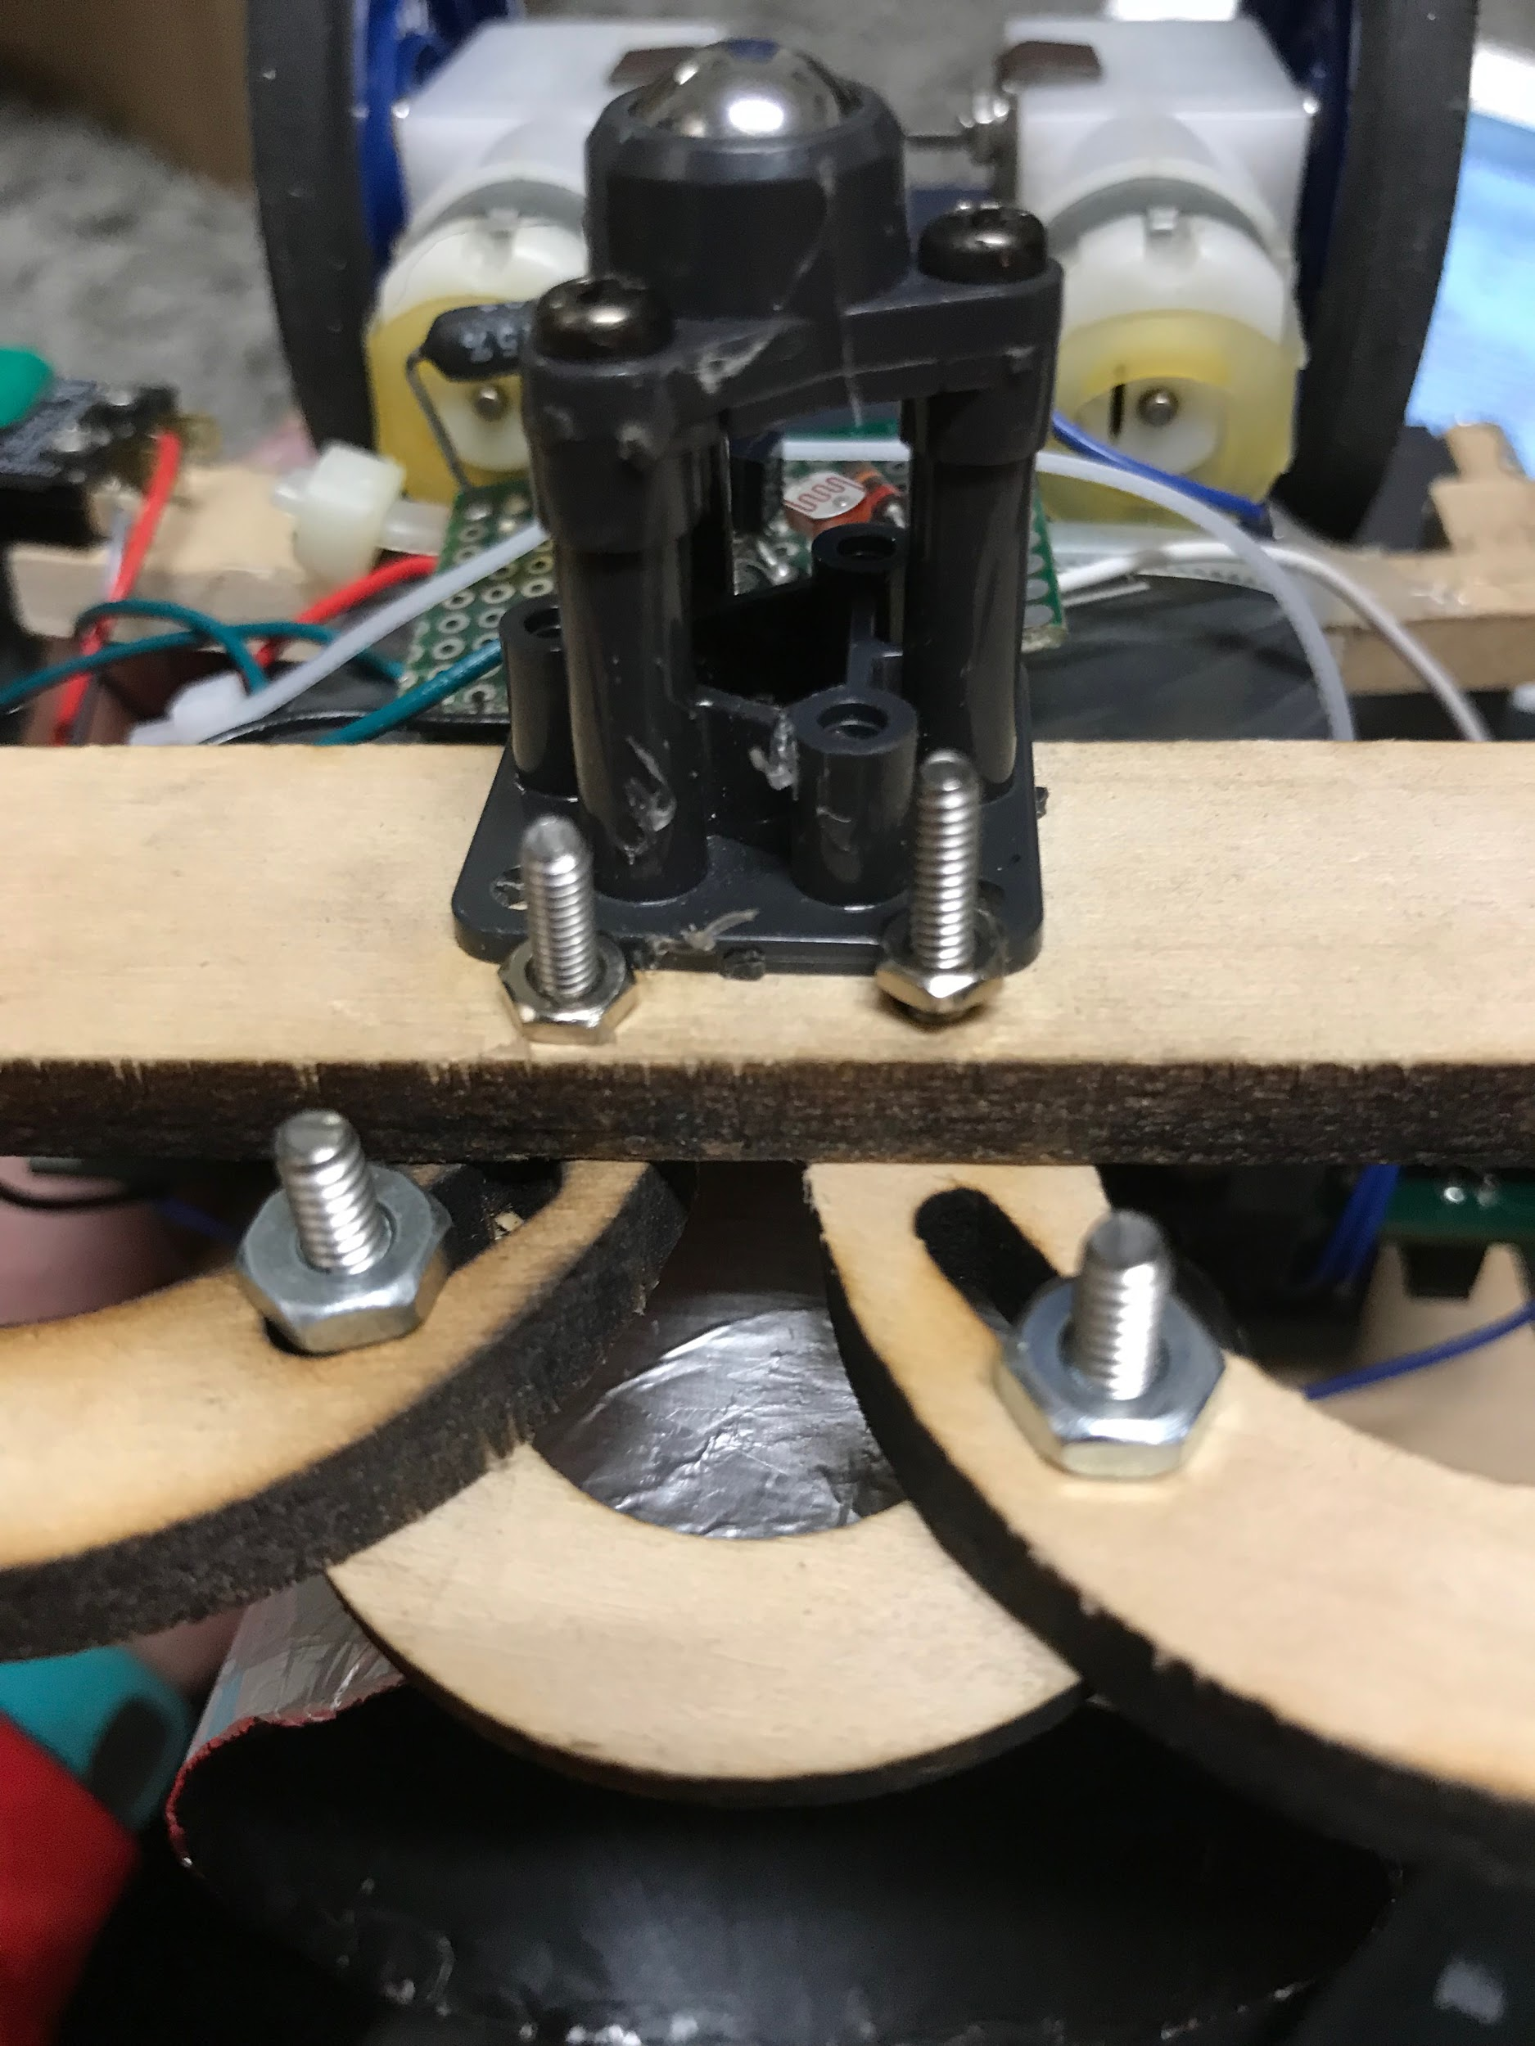

The bumper switches were attached to their mounts using screws and bolts (Figure 2.2) but their mounts were attached to the chassis using hot glue due to the lack of available space next to the battery packs (Figure 2.3).

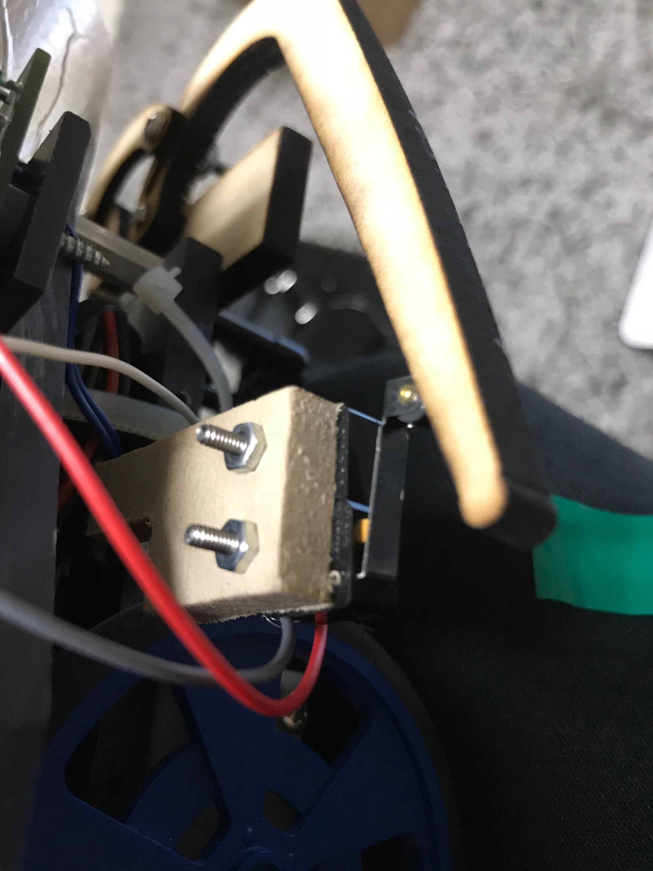 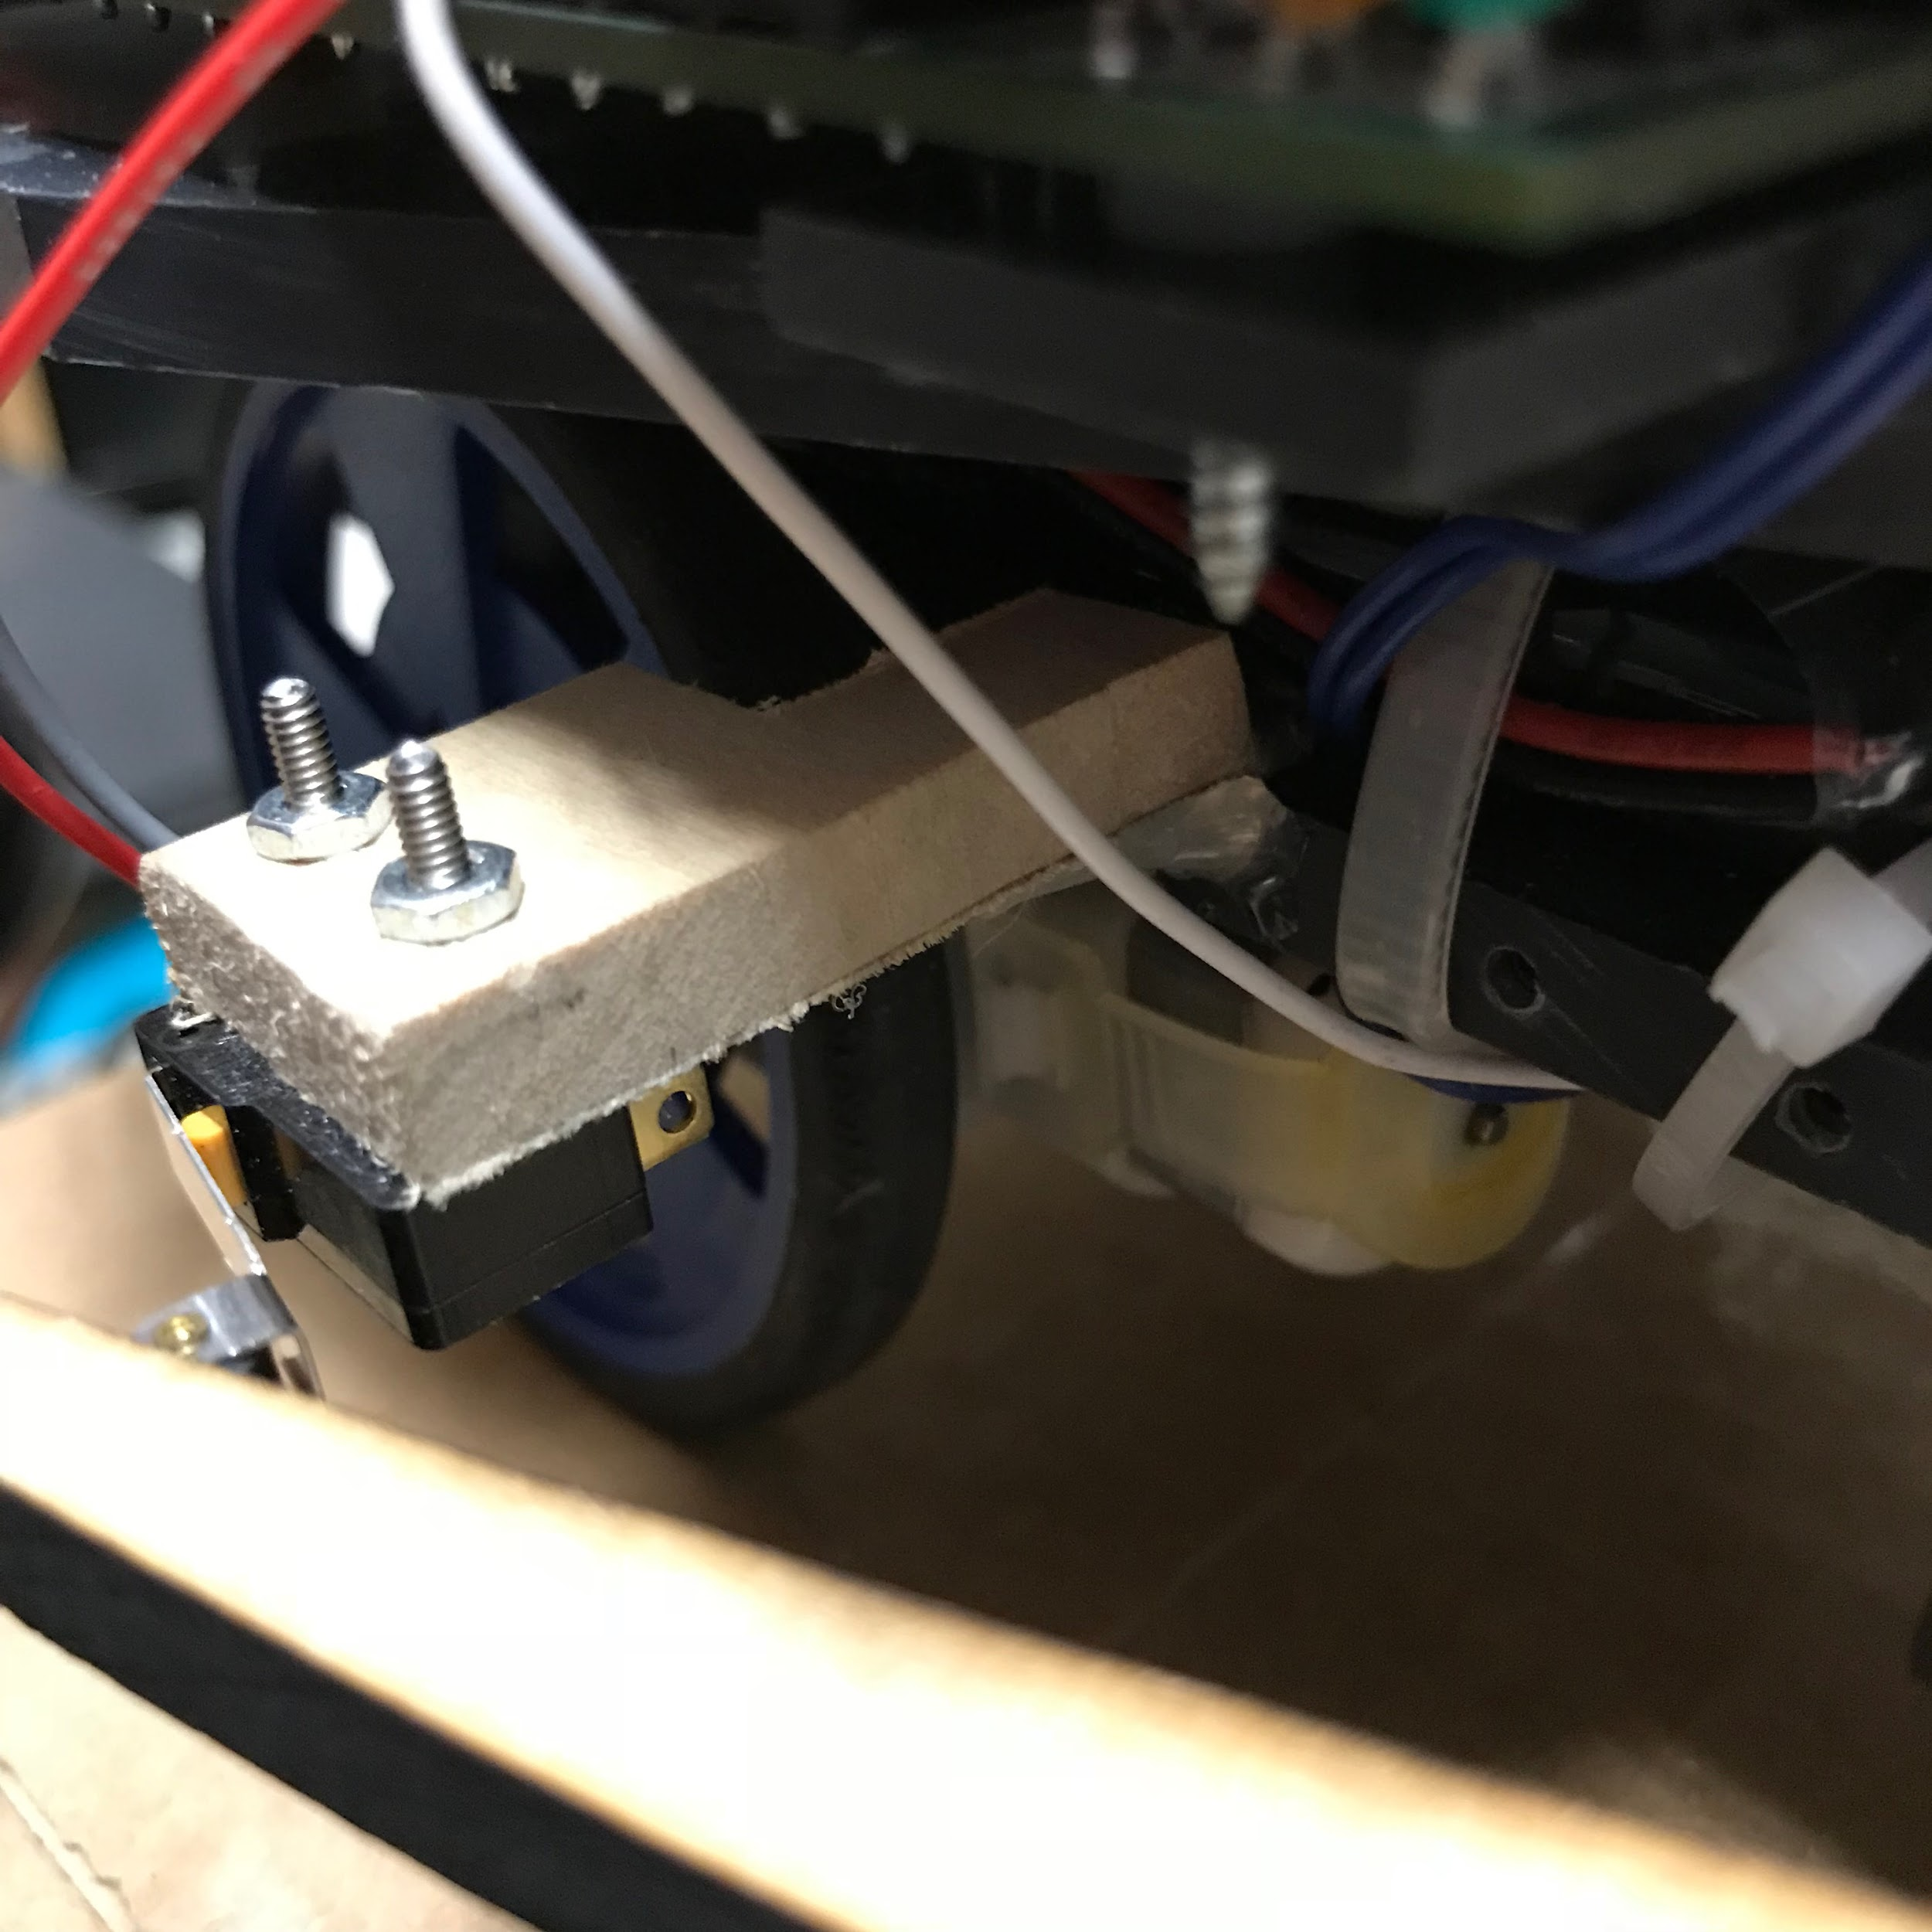

The floor sensor module was attached using a zip tie in order allow for adjustments to be made relatively easily (Figure 2.4).

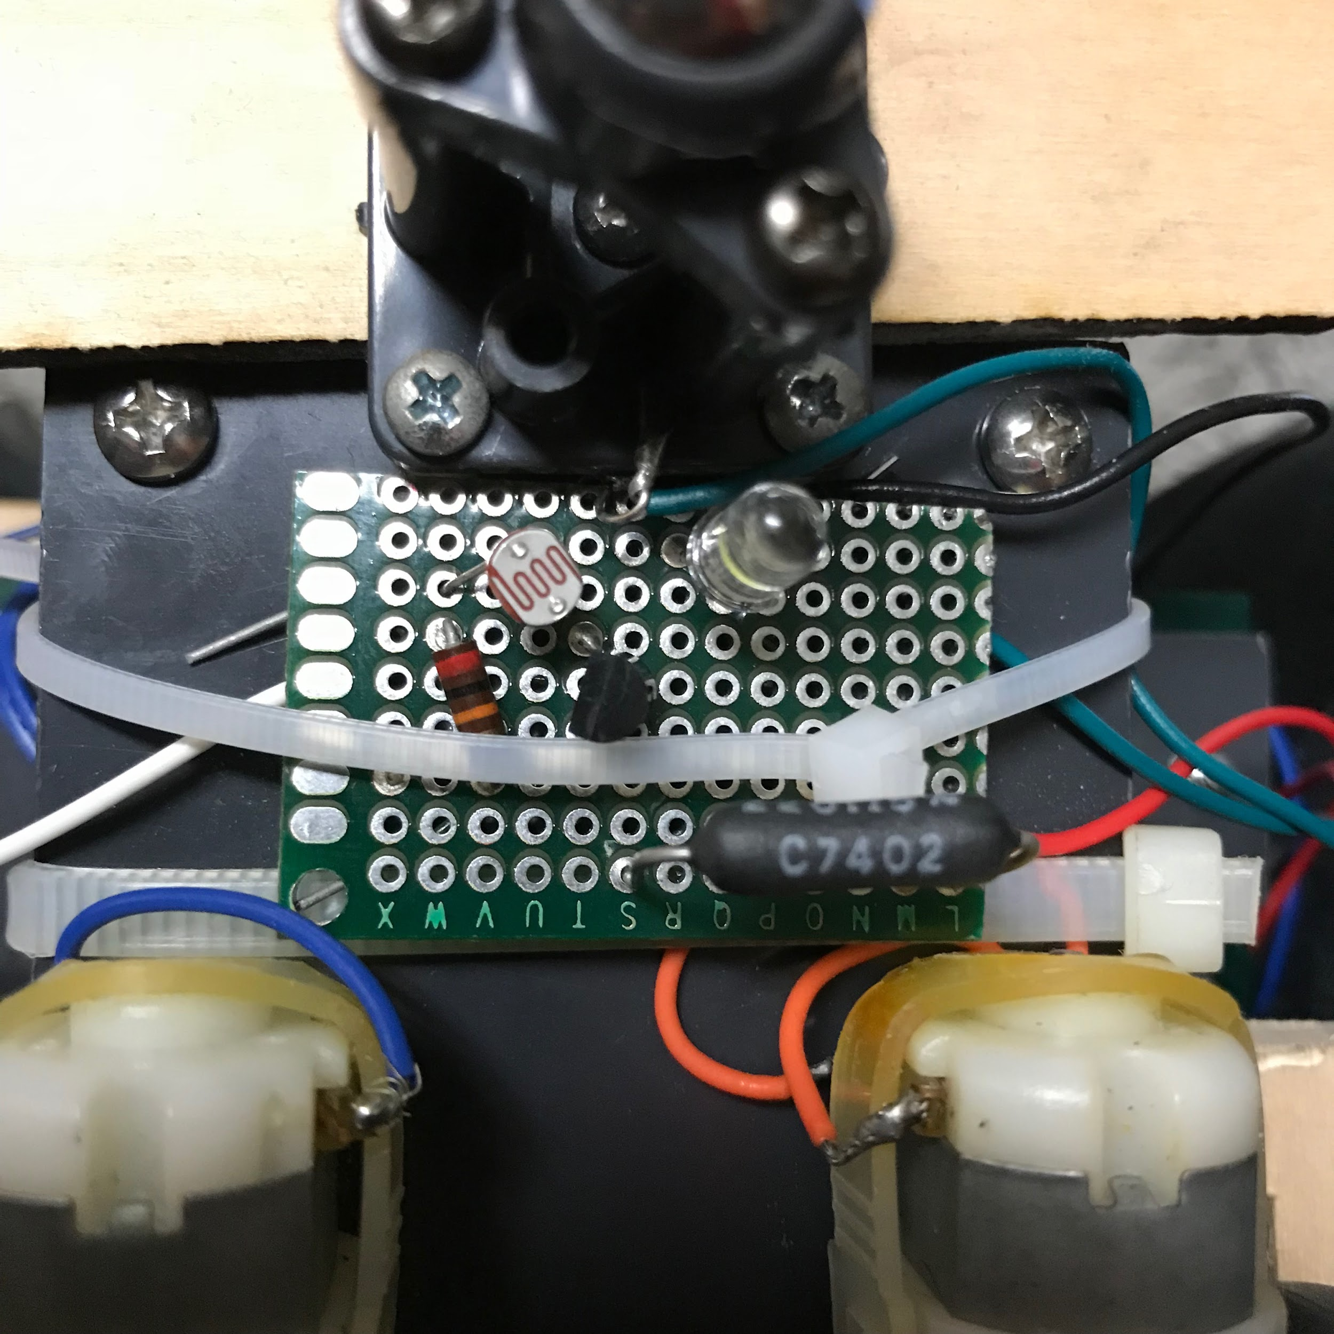

The tower and navigation light sensor were both attached using hot glue since they used cardboard. The casing of the chassis was mounted using screws, bolts and hot glue due to lack of time and space (Figure 2.5).

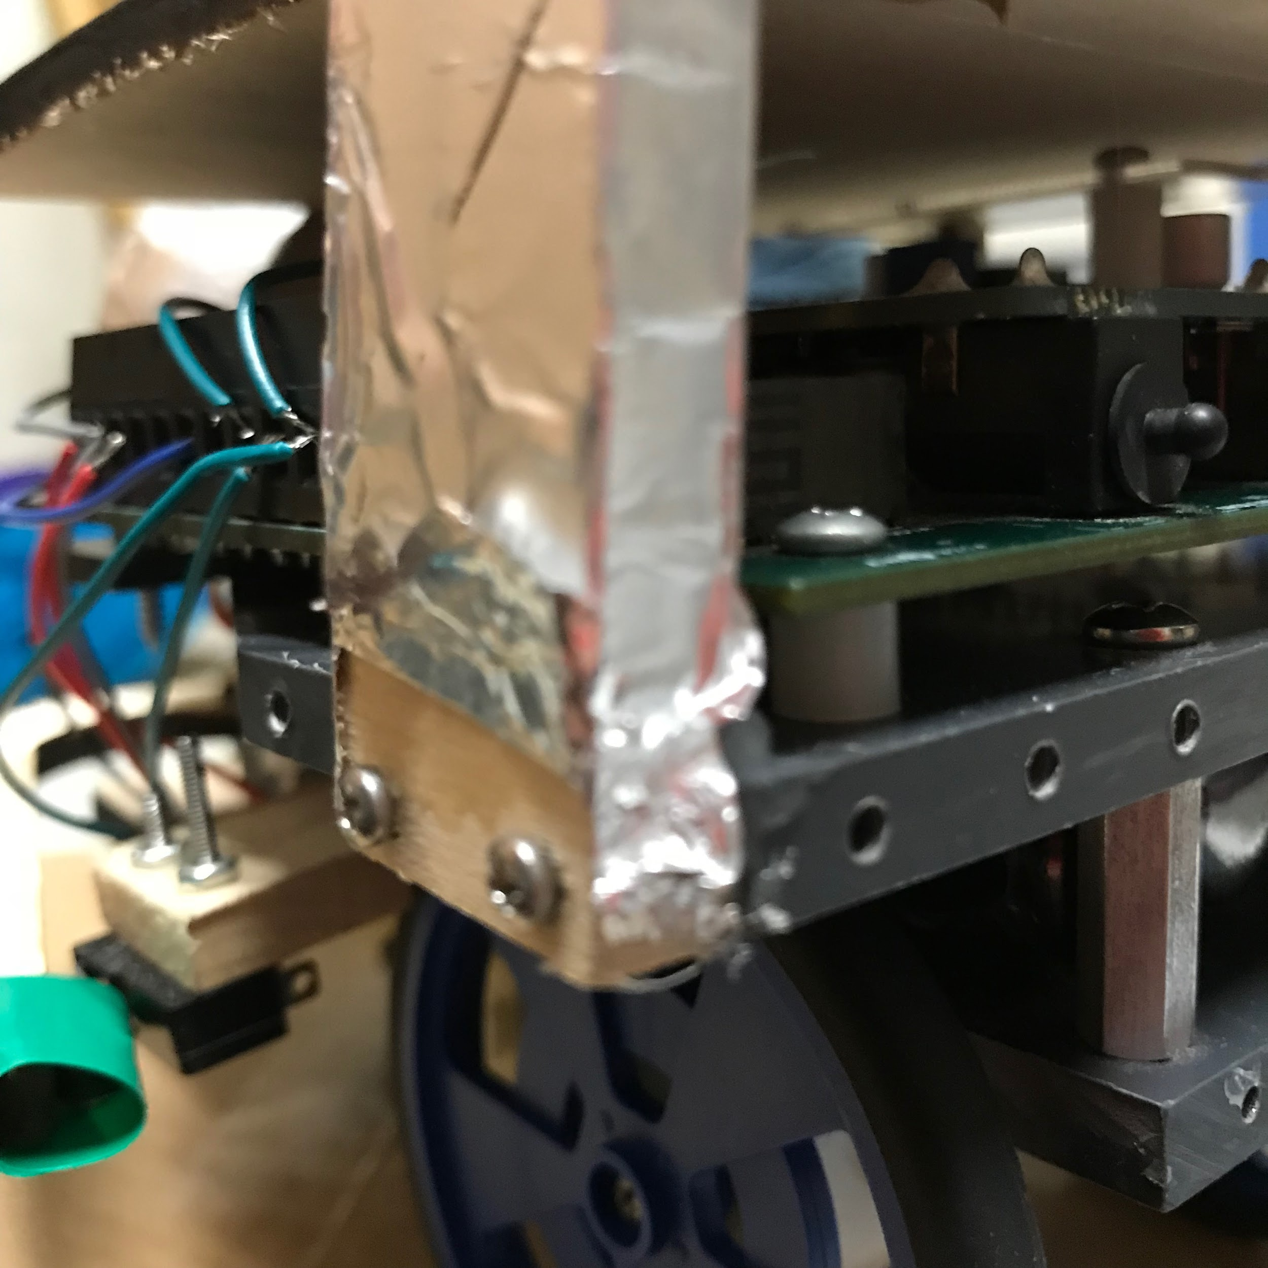

For the floor sensor module (FSM), the team inserted a 220 Ohm resistor, 20 Ohm resistor, transistor, LED, and light sensor into a small circuit board. We added electrical wires to each component and soldered each component to its respective wiring so that the floor sensor wires are secure and won’t fall off. To mount the FSM we used a zip tie, so incase we needed to make modifications to the FSM or to change its positioning, it would be easy to remove the zip tie and make changes.

The target light and navigation light sensors were covered using plastic cups which were cut to the appropriate height and angled accordingly. In order to ensure the cup was the as effective as possible the inside of the cup was painted a matte black (Figure 2.6). The outsides of the cups were covered in tin foil (Figure 2.7) in order to disrupt other robots.

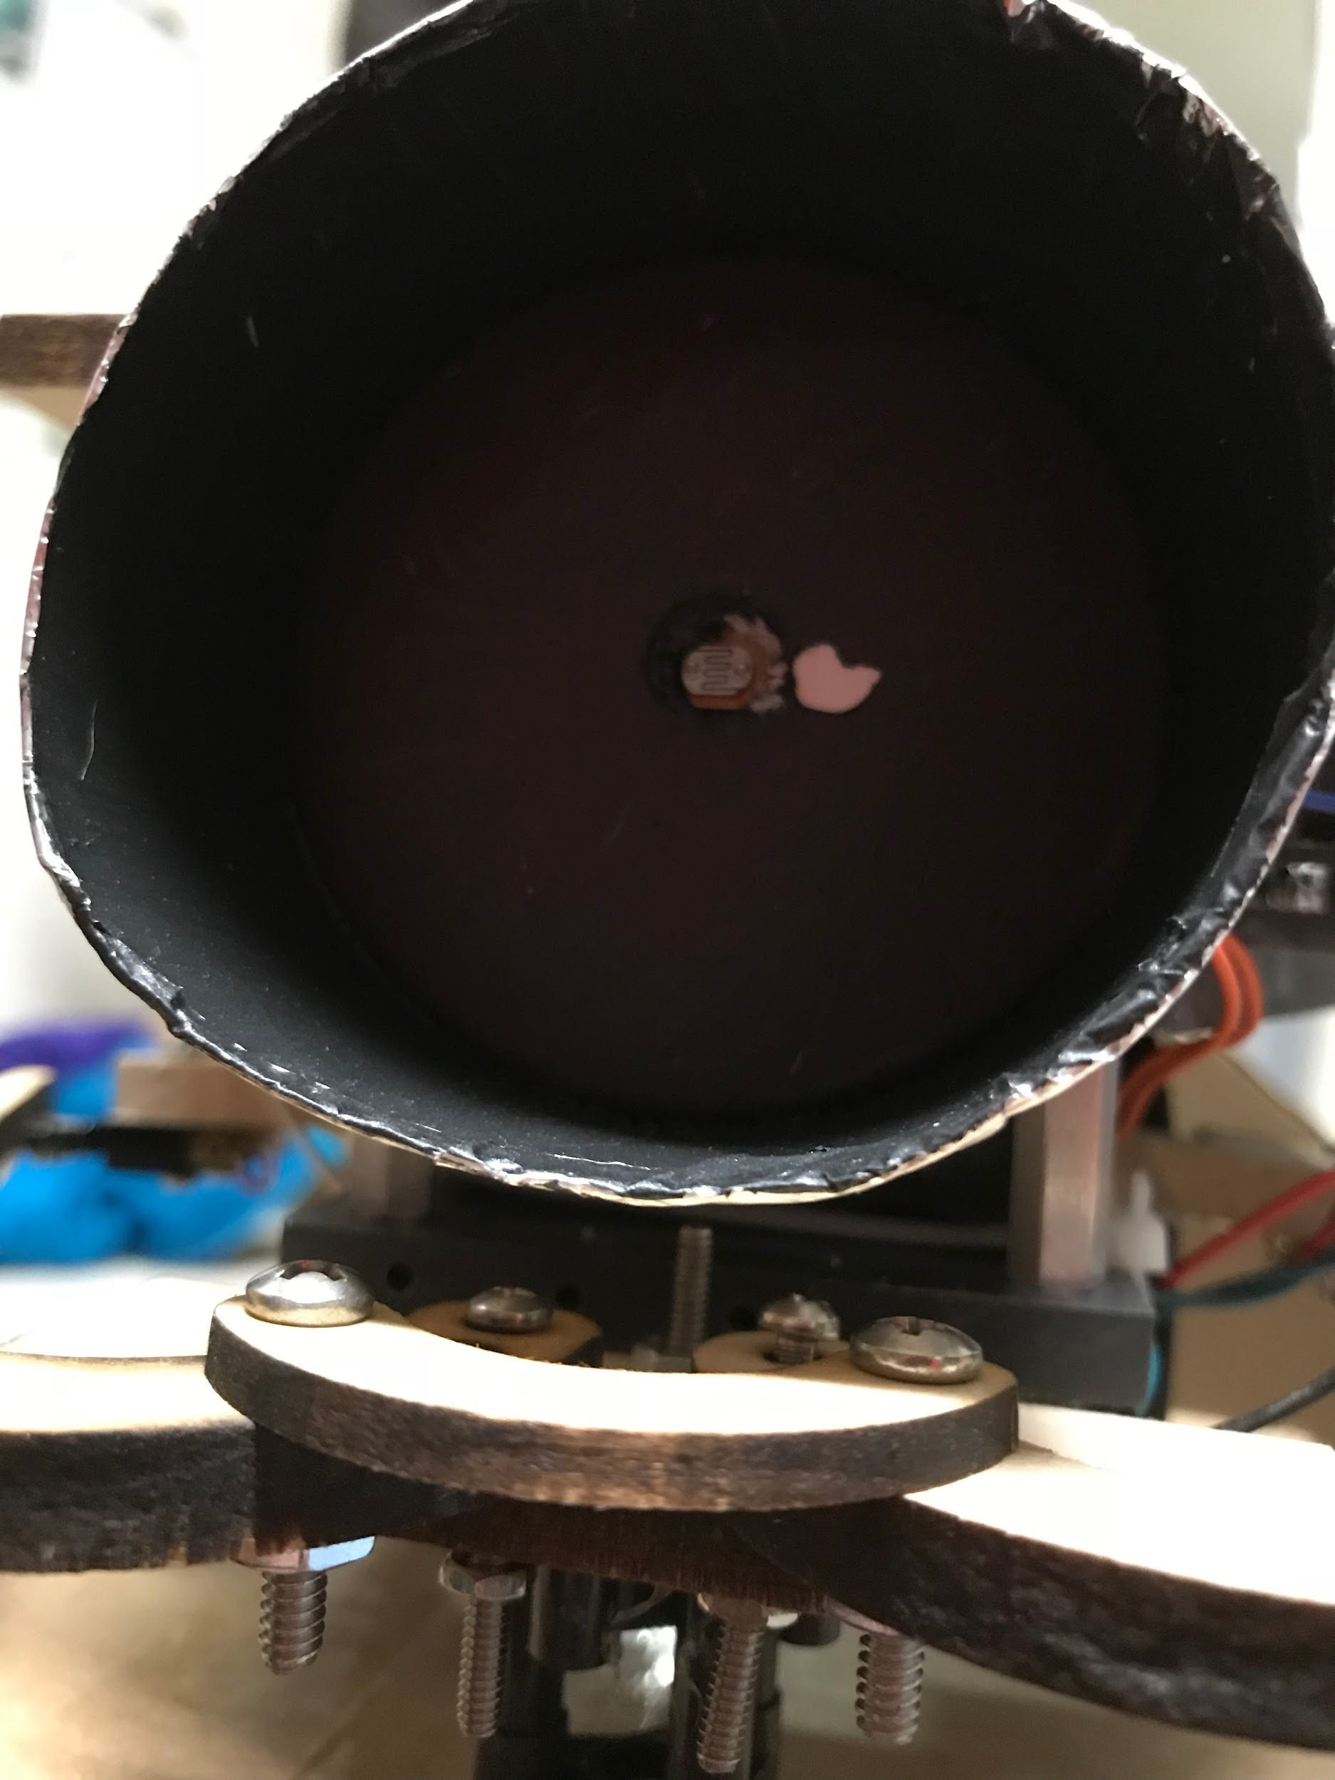 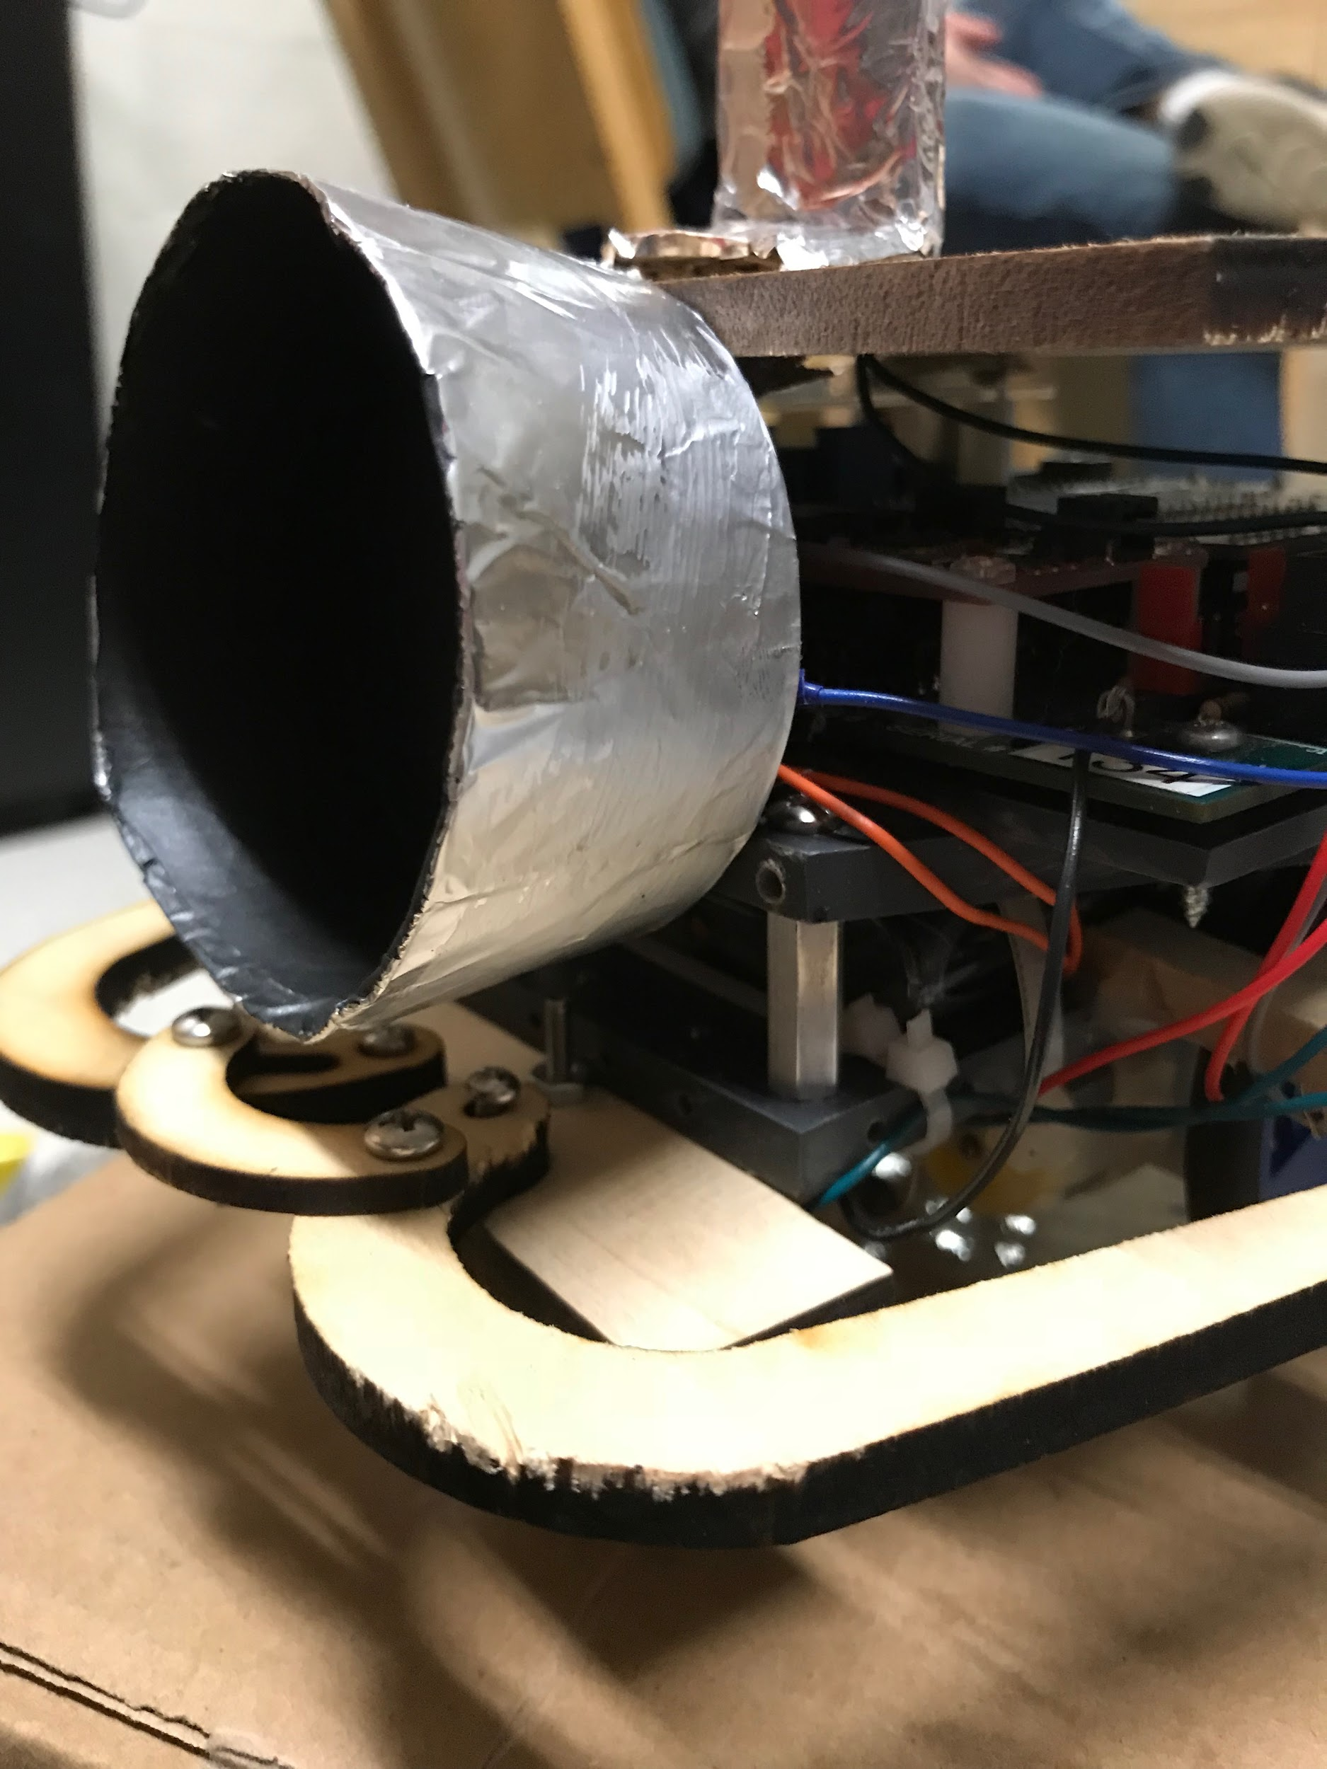

Bumper Design

When designing the bumpers initially, previous designs were examined for ideas and through a Pugh Matrix (Table 2 above) it was decided that a three piece bumper system with two bumper switches would be the most accurate while also being the most efficient as far as time and materials was concerned. The initial design (Figure 3.1) was similar to the final design when it came to components.

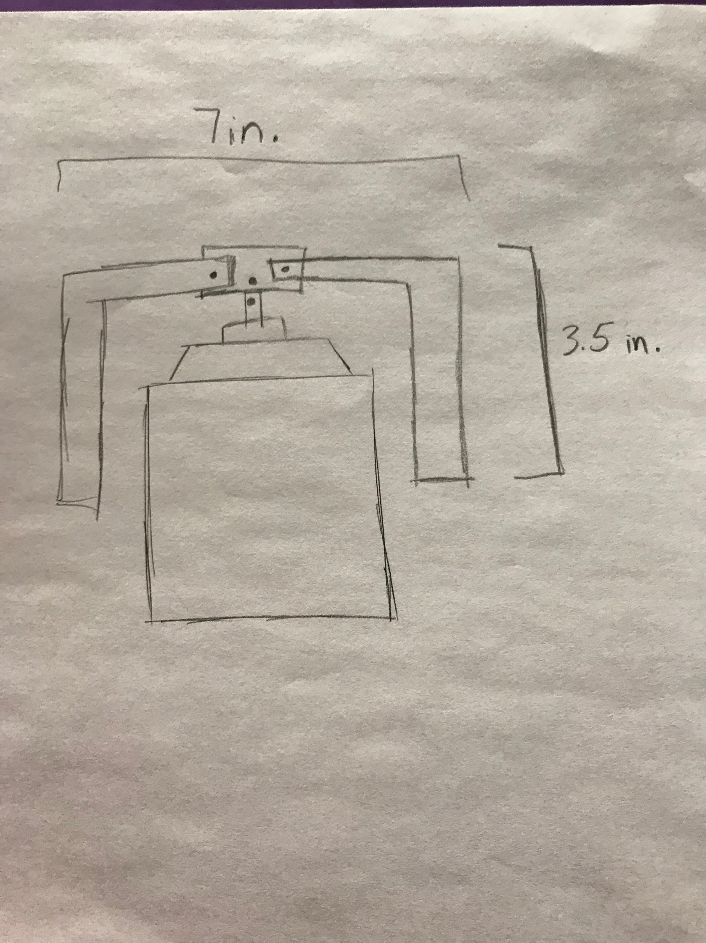

It had a more rectangular shape which was quickly decided would be too wide to maneuver the course and would use more material than was necessary. To fix these problems, a more rounded design was drafted and laser cut onto cardboard (Figures 3.2). Upon observing the prototypes, the holes which were cut for mounting the bumpers using screws were too wide for any screws which were available (Figure 3.3).

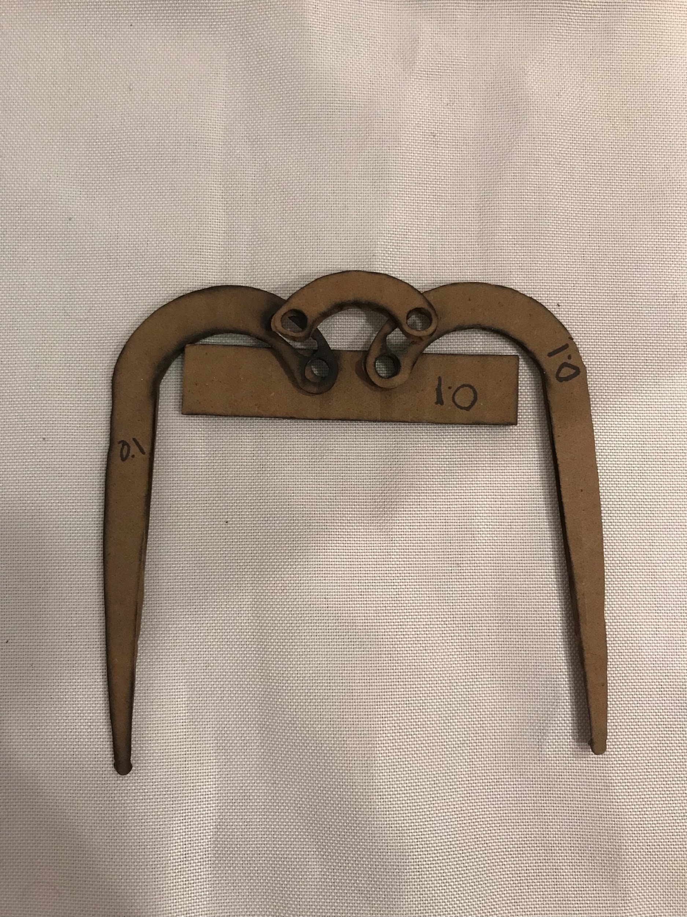 

The location of the mounting holes also needed to be adjusted in order to accommodate for the size of the screw heads. The design was altered from a narrow rectangular piece with two mounting holes to a wide rectangular piece with one mounting hole in the center. After making the small adjustments to the hole size and location (Figures 3.4 & 3.5) another problem soon arose when testing the bumpers with the bumper switches (Figure 3.6).

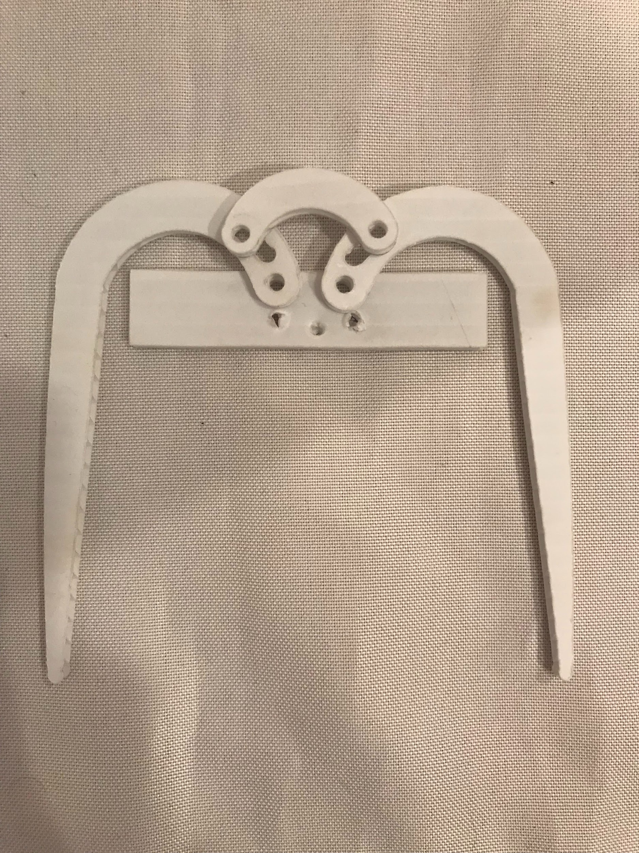 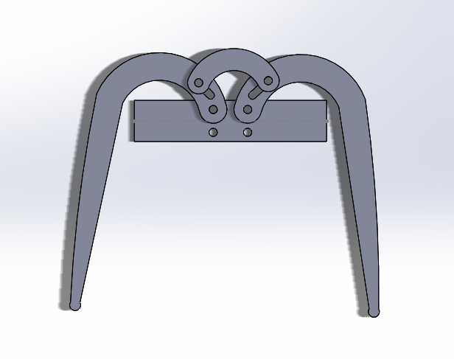

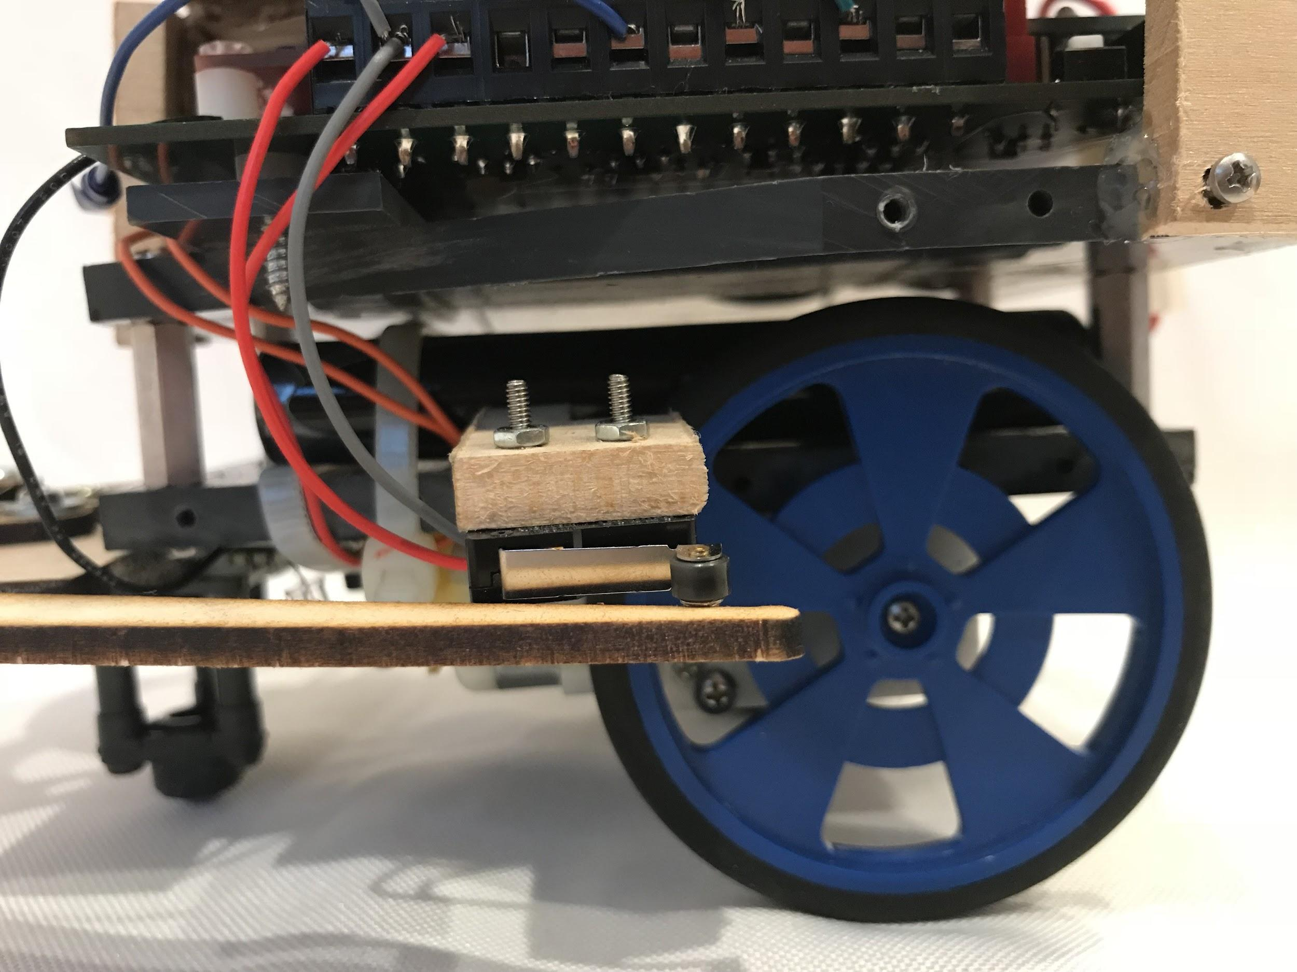

The switches were mounted too high for the bumper to hit, in order to solve this issue cardboard rectangles were added to the ends of each bumper in order to increase their width and allowing them to accurately trigger the bumper switches (Figure 3.7).

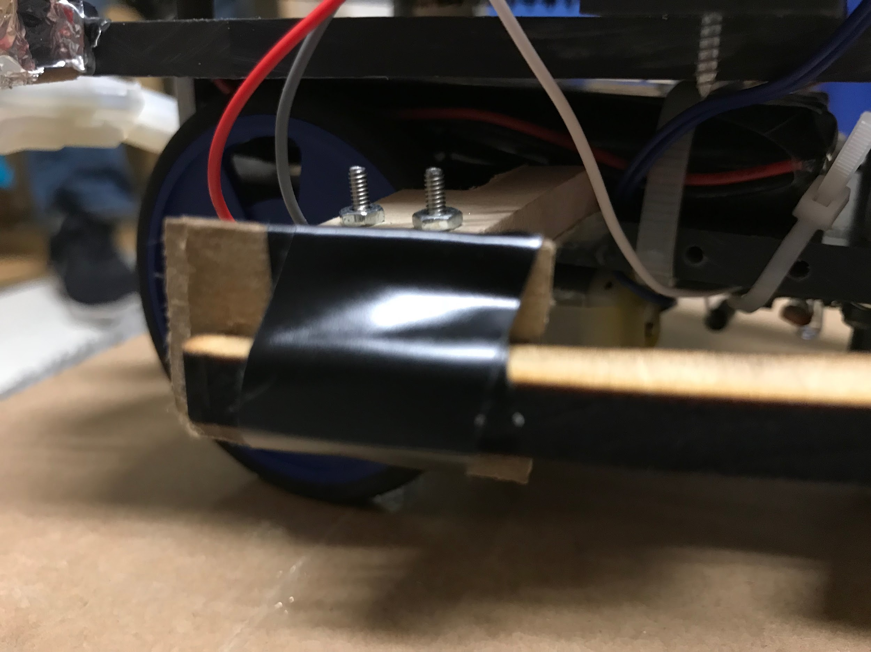

Once it was determined that this design was sufficient, it was laser cut out of basswood since it was the most time efficient. It was mounted using #2 screws and bolts of different lengths (Figure 3.8).



Logo Design

Our logo was a crown and it was laser cut onto the basswood platform which lies on top of the chassis. We thought a crown was a simple, but elegant design. By laser cutting it into the wood it conserves space, while looking elegant because of how it is engraved in the wood (Figure 4.1 and 4.2).

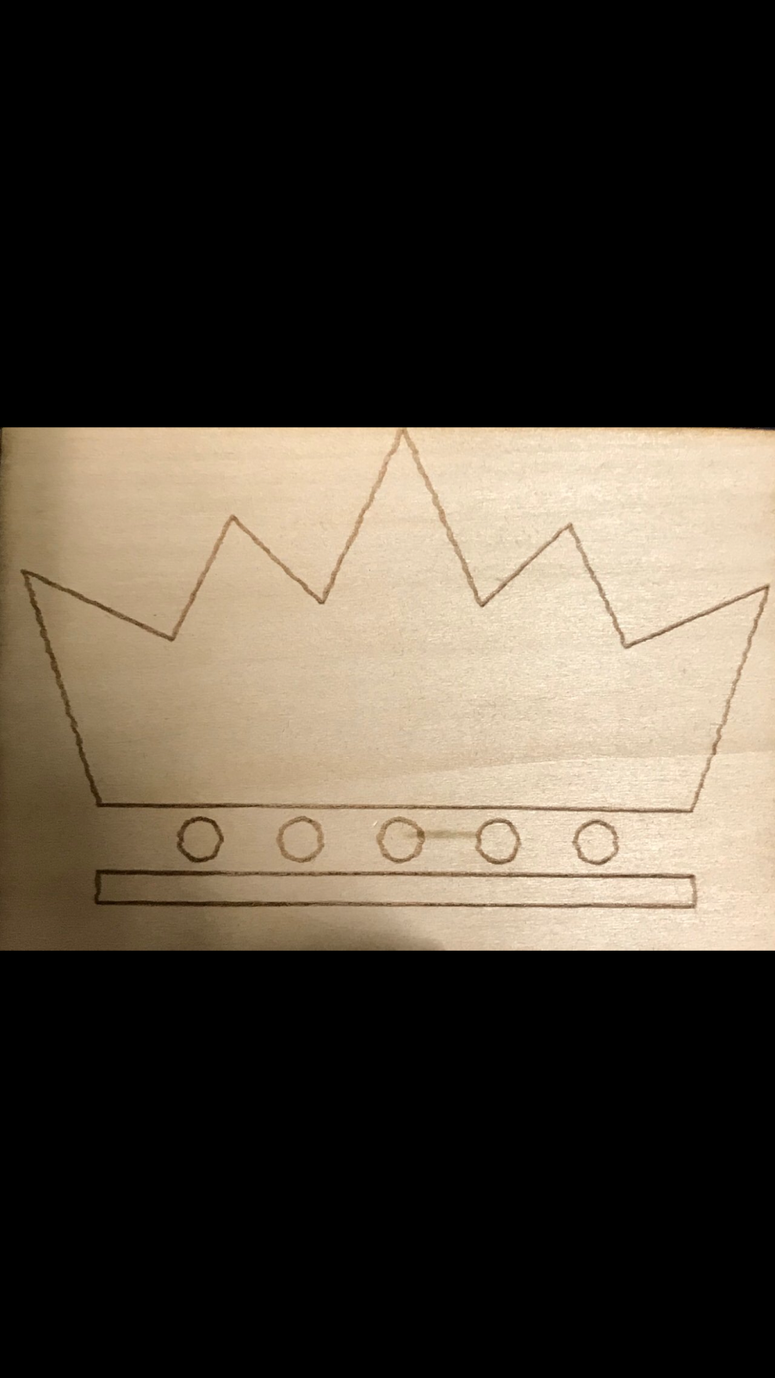

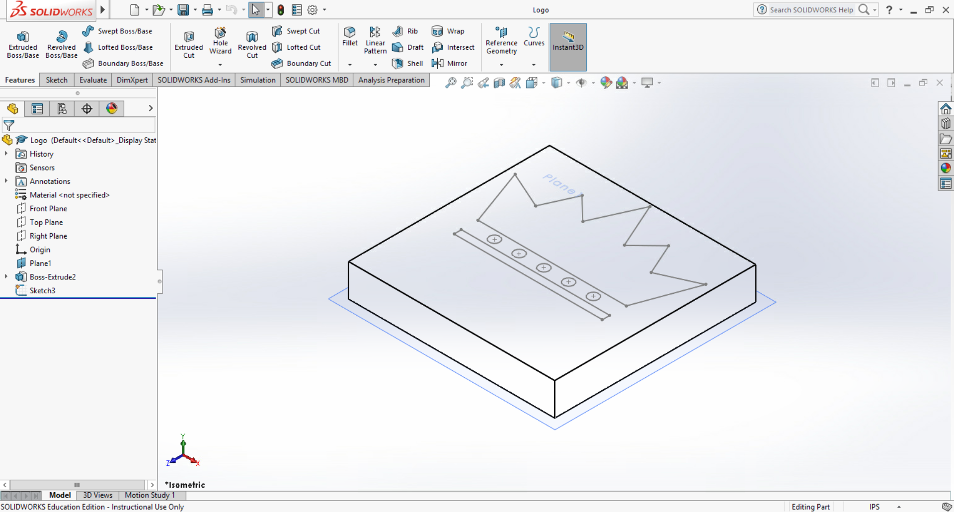

Software Design and Coding

In order to facilitate the design of the software The Arduino IDE was used as well two predefined support libraries, Arduinoinit as well as SendonlySoftwareSerial. These two libraries assist in providing predefined functions to be used in software design for the robot such as motor control and receiving information from different ports on the arduino. Using the provided flowchart as a guideline, as well as creating separate flowcharts based off of the chosen design The code was able to be planned and built efficiently and correctly. When it came to testing the code the serial monitor built into the arduino IDE was used in order calibrate sensor values to be placed in the code that allowed the robot to function properly in the arena.The serial.print() function allows one to display values of the light sensors in real time. An example snippet of code which can be used to print to the serial monitor is provided below. (Figure 5.1)

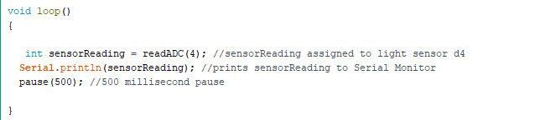

The predefined libraries were the main software tool used to design and develop the code while the serial monitor was the main software tool used to test the code. Other basic software tools were used during the design of the code such as the ability to verify the code by checking for correct nomenclature as well as any missing brackets or semicolons.

**Software requirements:**

1. Identify the robot’s home territory / team
2. Turn to locate the navigation light
3. Approach enemy territory
4. Identify First target Light
5. Hit first target Light
6. Identify second Target Light
7. Hit second Target Light
8. Ability to maneuver in case of bumper interrupt / collision with terrain
9. Complete these tasks in under Three minutes

**Subroutines:**

The Final code originally included 7 distinct subroutine functions, however through testing and evaluation this number was cut down to 6 after two subroutine functions regarding finding and hitting target lights were combined. These distinct subroutine functions do not include the setup or loop functions

1. **leftInterrupt()**
   1. This function works through the attach interrupt command and hardware override meaning that it is never explicitly called through either the setup or loop functions but rather called upon a bumper press attached to pin D2 (the left bumper switch). When triggered the function follows a sequence of events. First both motors halt movement, nextly both motors move back at 45% speed for 150 ms, next motor 1 moves forward at 45% speed for 150 ms, at the same time motor 2 moves backwards at 45% speed also for 150 ms. The end result is that the robot will have moved backwards and to the right upon a bumper press from the left. This subroutine aims to satisfy software requirements #8 and #9.
2. **rightInterrupt()**
   1. This functions also works through the attach interrupt command and hardware override ability of the Arduino. When pin D3 (the right bumper switch) is triggered the function starts by halting the movement of both motors. Following that both motors then move backwards at 45% speed for 150 ms. After that Motor 1 moves backwards at 45% speed for 150 ms while motor 2 moves forward at 45% speed for 150 ms. The end result of this function is that the robot will have moved backwards and deviated to the left. This subroutine aims to satisfy software requirements #8 and #9.
3. **findNavLight()**
   1. This function works by firstly creating an integer type variable **navigationLightReading**, the function then stores the light sensor reading from pin A3 (The light sensor attached to our navigation light platform) as that variable. The function then uses a while loop using the value stored in navigationLightReading as a parameter and rotates the robot until the navigationLightReading value is under 20,000. Once this condition is satisfied The function is resolved and the program continues. The end result of this subroutine is that the robot should be oriented in a way where it can now approach the enemy territory. This subroutine function aims to satisfy software requirements #2, #3, and #9.
4. **whiteMoveForward**
   1. This function works by firstly turning on the LED on D4 attached to our floor sensor module. The function then creates a int type variable **sensorReading** which stores the floor sensor reading after the LED has been turned on. The function then uses a while loop which is satisfied while sensorReading < 15000. When this condition is met both motors move forward at 60% speed for 500 ms, after this the motors come to a stop and sensorReading is once again read. If the new value is greater than 15000 then the robot assumes it has reached the enemy territory and the function is resolved. Once resolved the LED is turned off. This function is only called if the home territory is determined to be white. The end goal of this function is that the robot will have reached the black side of the board (The enemy territory in white’s case). This subroutine function aims to satisfy software requirements #1, #3, #9
5. **blackMoveForward**
   1. This function works exactly the same as **whiteMoveForward()** except for the fact that the while loop has different parameters and resolve conditions to account for the black side. While sensorReading > 15000 the while loop persists and it is resolved after the new sensorReading is < 15000. When this requirement is met the robot assumes it has reached the white side (The enemy territory in the case of black being the home side). This subroutine function aims to satisfy software requirements #1, #3, and #9
6. **findTargetLight()**
   1. The purpose of this function is to locate and hit the two target lights in the arena. The functions tarts by first creating an int type variable **targetLightReading** and stores the light sensor reading connected to pin A4 as it. The function then has a while loop which loops as targetLightReading > 5000. Within the while loop the robot rotates at 20% speed in 100 millisecond intervals and rechecks the targetLightReading to see if the while loop is resolved. Once resolved the robot assumes that it is in line with the target light. Nextly another while loop is used with the parameters that targetLightReading < 5000. Within this loop both motors move forward at 60% speed in 300 millisecond intervals, rechecking the targetLightReading every time. Once the target light is hit the value should exceed 5000 and the while loop is resolved which in turn resolves the function. This function is present within the main loop function so once called it should loop until both target lights have been activated. This subroutine function aims to satisfy software requirements #4, #5, #6, #7, and #9.

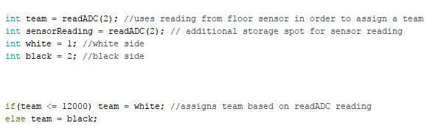

The above snippet (Figure 5.2) is an algorithm found within the setup function used to decide whether The home territory white or black, it is essential in setting up the code and the sequence of events following it.

**Unique features:**

The design is unique in the sense that it tries to use as little resources as possible. Only one light sensor is used to detect target Lights and there are only two bumper pins and interrupt features. The philosophy behind this decision is that it leaves less room for potential errors or failure. The simplification of design also makes designing adequate software easier and more straightforward. For example the inclusion of only one target light sensor allows the robot to easily rotate in order to identify potential target lights.

**Computer Interrupts:**

Computer interrupts were used in conjunction with the attachInterrupt function and two bumper pins in order to maneuver the robot by changing its course in the case of a collision with a wall or piece of terrain on the Course. As stated in subroutine design there are two distinct interrupt functions and neither are explicitly called within the program but called only through a hardware override on the Arduino board.When the interrupt functions are called and executed the program returns to the state it was in previously before the collision and continues from that point.

**Software Flowcharts:**

1. Setup
   1. The setup function first starts by initializing the hardware as well as the attach interrupt functions. Nextly it rads and stores the floor sensor reading and assigns a team based in that reading. Next comes the first decision box. This determines if the navigation light is in sight, if it is the robot moves forward, if it isn’t the robot rotates at 40% speed for 100 msec. When that condition is resolved the robot will then move forward at 60% speed in 500 msec intervals. The next decision box is to determine whether or not the robot has reached the enemy territory. If it has the motors are halted and the setup function is resolved, if it has not yet reached the enemy territory the program loops once again and the robot moves forward at 60% speed for 500 msec once again. This is looped until the robot has reached the enemy territory.
2. Bumper Interrupt
   1. The interrupt function starts with a 5 msec pause, this is to allow time for a bumper press. Nextly comes the first decision box with aks if both bumpers are not pressed, if this is the case the function is resolved, if not both motors are turned off and there is a 100 msec wait time to account for the time it takes for the motors to stop without causing any sort of damage. Nextly the function asks if a bumper is pressed, if no bumper is pressed the function is resolved, if a bumper is hit then both motors move backwards for 150 msec and depending on the right / left interrupt motors 1 / 2 move forward / backward at 45% speed for 150 msec. The function then loops at this point and once again asks if a bumper is hit.

1. Loop
   1. The Loop function starts by assigning and storing a target light sensor reading. The Function then asks the question is the sensor reading > 5000, if the answer is yes then motor 1 moves forward at 20% speed, motor 2 moves backwards at 20% speed for 100 msec, the program then reassigns the target light sensor reading and once again asks if the sensor reading > 5000 ( The function loops at this state). Once the sensor reading is less than 5000 the next decision box is satisfied and both motors move forward at 60% speed for 300 msec, the function then reassigns the sensor reading and the function loops until the sensor reading is greater than 5000, meaning that the target light has been successfully hit. The function then loops until both target lights have been triggered.

Electrical and Wiring Design

Arduino consists of a software program (IDE) which is in C, and a physical circuit board (Figure 6.1 at the bottom). The Arduino board is a microcontroller with digital input/output pins that are used to connect sensors, LEDs, resistors, etc. To connect the various sensors, we used electrical wiring and stripped the tips of the wires to connect to the end of the sensors, LEDs, and resistors to the board pins. To fasten the pins, you use a screwdriver so that the electrical wires are securely fastened.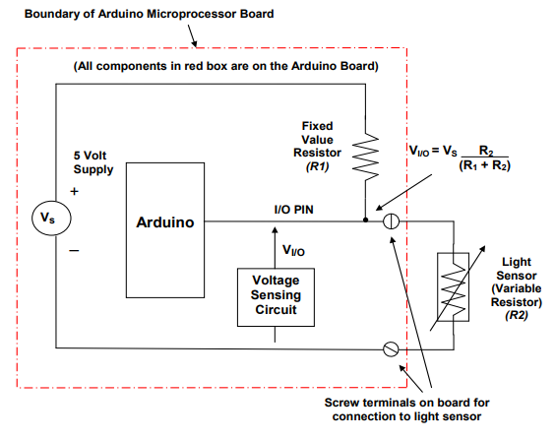

There were various ways the team completed the electrical design that made our robot unique. Firstly, the floor sensor module was placed on the bottom of the robot but towards the front. We did this because we wanted the robot to detect when it reaches the enemy side as soon as possible, and search for the target lights. We soldered the wiring in the floor sensor module, and used a zip tie to fasten it to the bottom of the robot. Secondly, we had to create sensors for the target light and navigation light. The Photosensitive Resistor Voltage Divider Circuit diagram below shows how the light sensor works (Figure 6.2 to the left). Basically, one side of the photoresistor connects to the ground input and the other connects to one of the analog inputs (A0-A5). The one target light in the front of the robot rests on a piece of wood. The team made the wiring tight so that the sensor would always remain vertical to the floor. To connect the electrical wire and the sensor we used electrical tape. For the navigation light, the team used a long 8 inch wire so that the sensor would not be interfered with light from the arena (target lights, or possible enemy decoy). Similarity to the target light, we connected the electrical wiring and the sensor with electrical tape. Lastly, the bumper switches were positioned on the side of the robot in the middle. The team tied the wiring to the C(common) and NO(normally open). The number of sensors we have, as well as the way they are fastened and positioned are unique aspects of our electrical design.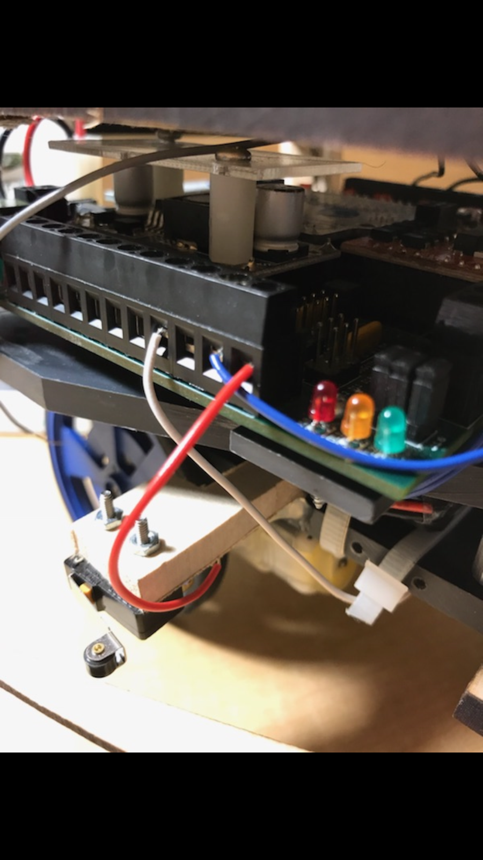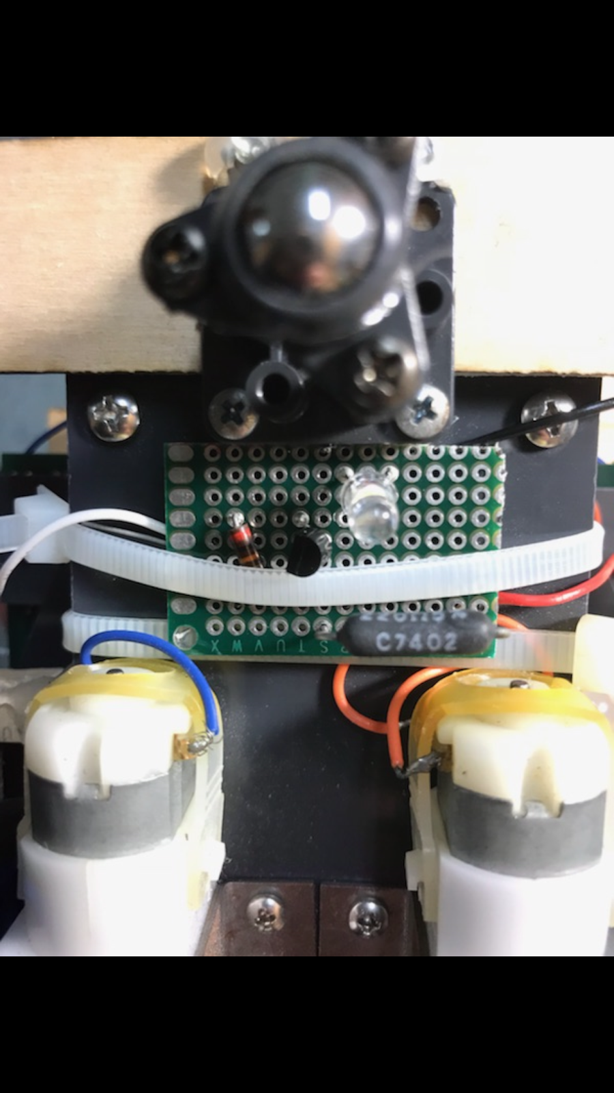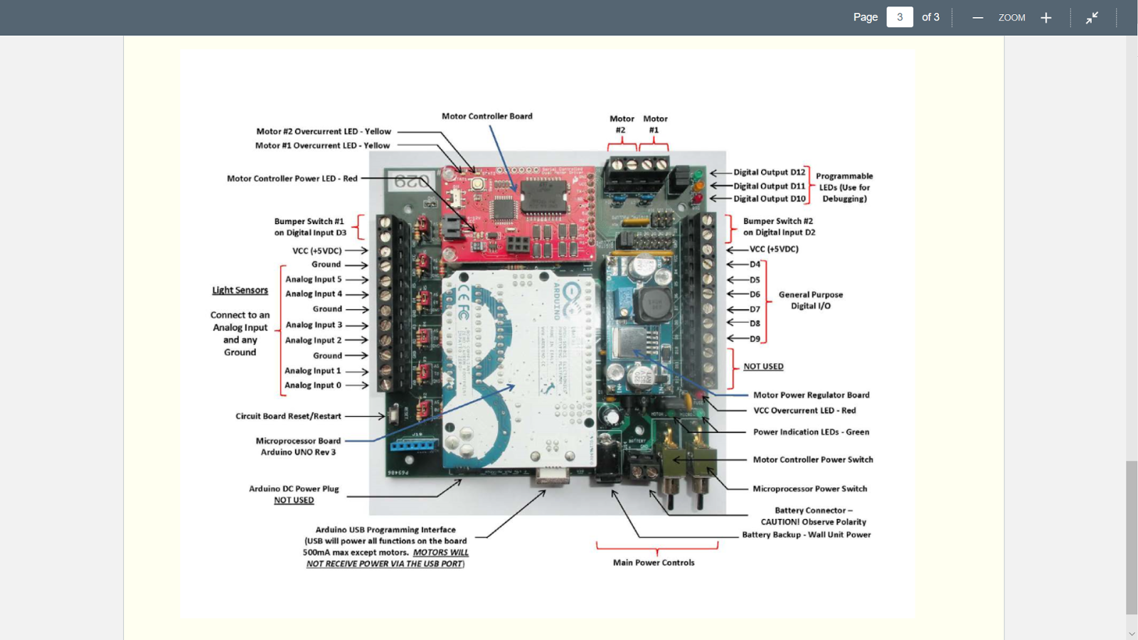

We used different colors for wiring to resemble different connections (Figures 6.3-6.6). For the floor sensor module, we used a white wire for the 20K Ohm resistor . For the target light sensors, we made both wires blue (one connected to A4, and the other to ground). For the navigation light, we made both wires green (one connected to A3, and the other to ground). For the bumper switches, we used grey wires for the ground input and red wires for the D2/D3 inputs. Using specific wire colors helps if there is a problem with the wiring, and when we need to know which input each wire is in for the code.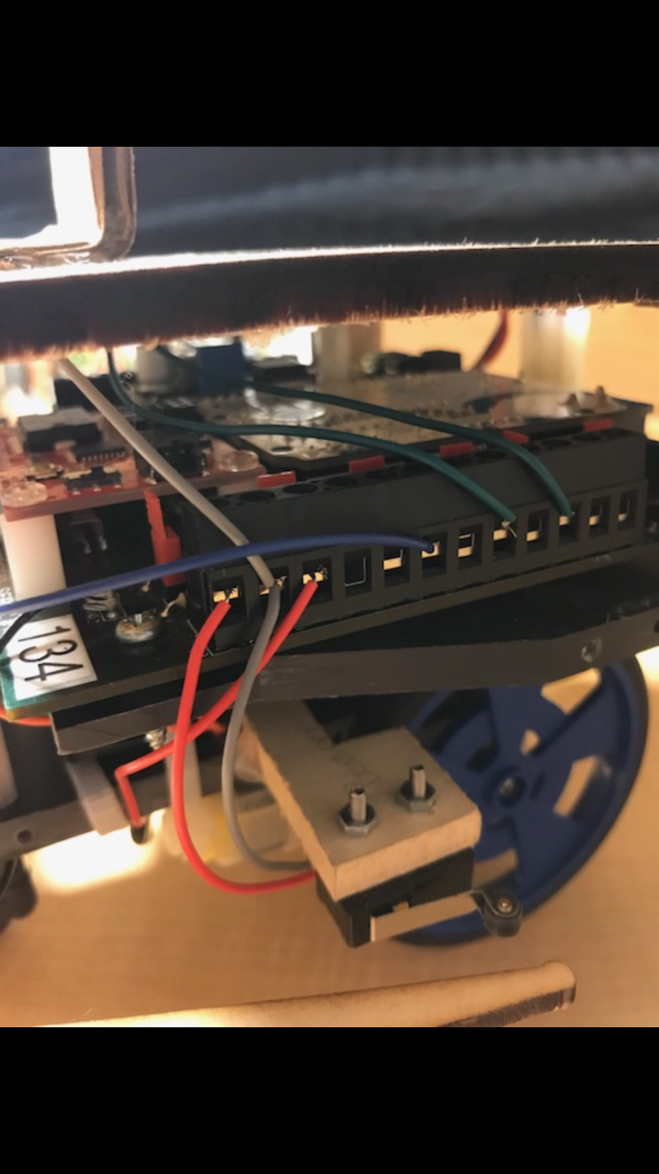

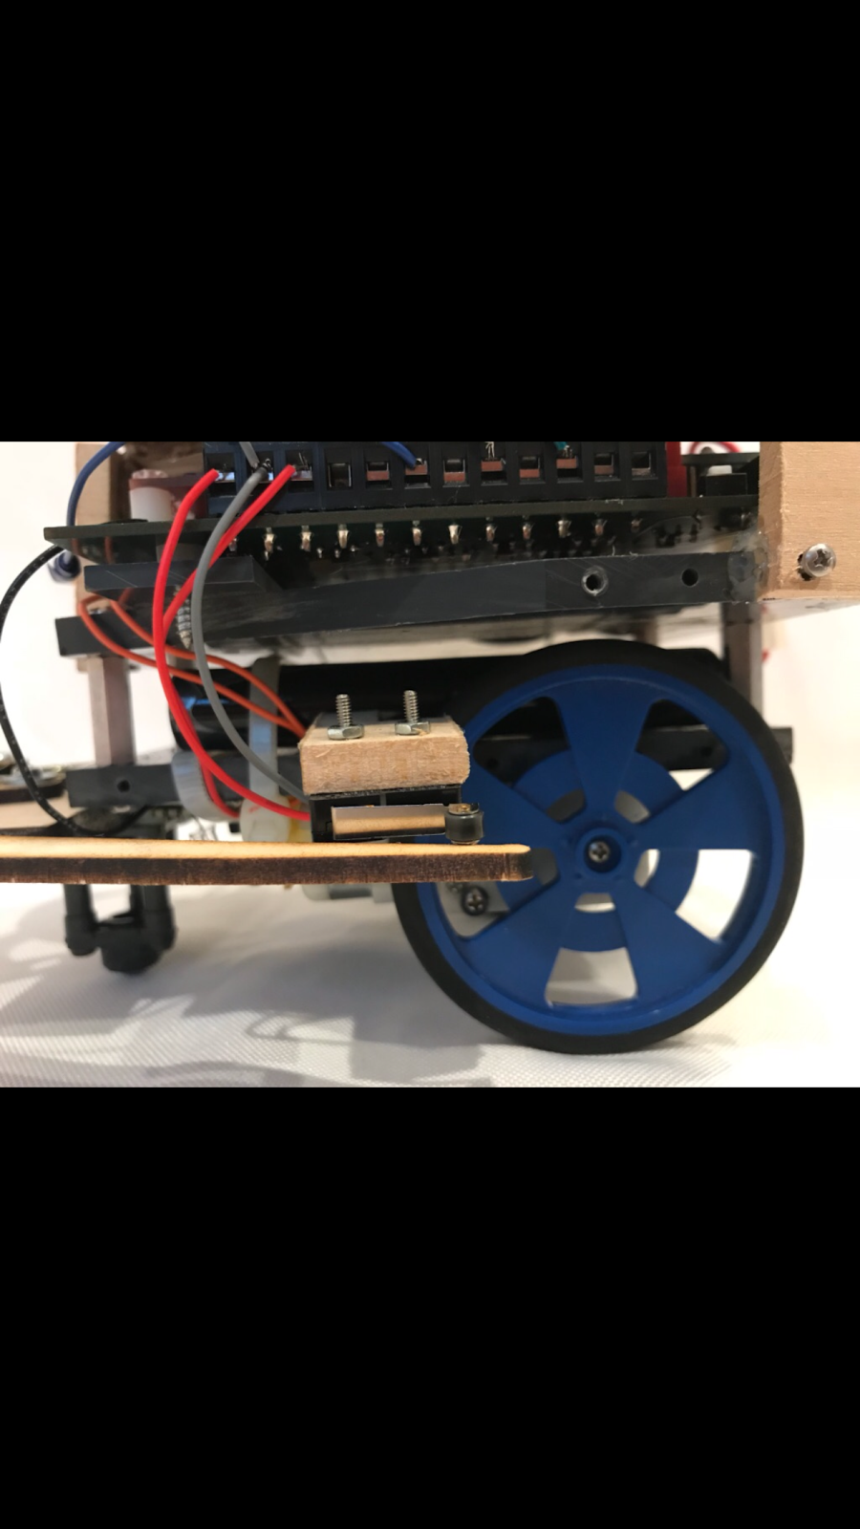

Assembly

When it came to assembly of the robot one aspect in particular was troubling. No team members knew how to solder initially. After completing a tutorial assembly of the electrical components was no longer an issue. Taking proper safety precautions were also necessary. Equipment such as goggles were necessary when using bench tools. Closed toe shoes and long pants were required in the lab as well.

* Materials
  + Cardboard for prototyping
  + Cardboard for final design
  + Basswood
  + Electrical wires (10)
  + Tool kit
  + Electrical Tape
  + Zip tie (1)
  + Black Matte Paint
  + Hot Glue Gun
  + Glue Sticks
  + Aluminum Foil
  + Small Paint brush (2)
  + “Mod Podge” (Adhesive)
  + Paper Cups (2)
  + Soldering Iron
  + Solder
  + Light sensors (3)
  + LED (1)
  + 220 Ohm resistor (1)
  + 20K Ohm resistor (1)

Components of the robot were held together using screws, nuts, bolts, hot glue, zip ties, and the aluminum foil was attached using Mod Podge (clear adhesive).

Tools

* Hand Tools
  + Phillips head screwdriver
  + Flathead screwdriver
  + Box cutter
  + Wire cutters
  + Ruler
  + Callipers
  + Soldering Iron
  + Wire stripper
  + Needle Nose plyers
* Bench Tools
  + Bandsaw
  + Drill press
  + Sander
  + Scrollsaw

Integration Testing and Evaluation

The way we tested our robot was to first test individual parts and then together with the code. For the floor sensor module, the team constructed it and made sure ir was getting a reading and the LED was bright enough. This was helpful because when we first constructed the FSM, the LED lit, but it was dim so we were able to fix it before soldering. For the target light and navigation light we constructed both and individually tested each when they were complete to make sure they got a reading. Finally we tested all the electrical components to make sure it worked with the code, and that the code had all the appropriate digital inputs needed. By using the gantt chart to assess what milestones needed to be completed first we were able to effectively complete all the tasks needed before fully testing our robot.

The major test milestones were completed at different times because we needed the mechanical and electrical components to be finished before we could test the code. The mechanical and electrical components were completed at the same time, and they consisted of constructing and mounting the bumpers with their switches, constructing and mounting the FSM, wiring the navigation light and constructing a structure for it to be placed high above the robot, and wiring the target light to the front of the robot.

The team did make some design modifications after testing. During testing the robot on the arena, one of the bumpers broke so we had to construct new bumpers that were more sturdier. The on board LED’s allowed the team to test our target light sensors and see if the code worked so that it would knock out these target lights. The sensors were calibrated by going on the arena and calculating the different readings needed for each sensor. The floor sensor module knew it was on the black side if the reading was roughly 34,000, the navigation light sensor looked for readings which ranged from 12,000 - 8,000, and the target light sensor looking for readings which were under 5,000 when looking directly at the target light. The serial monitor was used to get values of each sensor so we knew what the reading was from each sensor.

Final Competition

The Process and Grading

The day of the competition we cannot use any of the class time to work on our robot. We will versus every robot in our class at least and after the first match we can make modifications to the hardware and software to fix any problems with the robot. If the robot has an unrecoverable or recoverable condition that prevents the robot from completing the objective such as a damaged wheel, or a dead battery the robot will be powered off or remained still and the enemy robot will be able to continue to compete. The only requirement to at least compete in the competition is to have working bumpers that works with the collision avoidance subsystem. If the robot is stuck in an obstacle and cannot escape within 10 seconds it will be powered off and the enemy robot will be allowed to continue to compete. If two robots collide and are not free within 10 seconds, both robots will be powered off. If it is the first match, a second match will be played otherwise whichever team had the most points will win. The competition will last for 3 minutes or until one team knocks out both of their enemy's target lights. The match starts with a coin toss, and no one is allowed to touch the robot when the competition starts.

The scoring works by a point system. You gain 5 points if you cross into enemy territory, or knock out the enemy target lights. You gain 10 points if you win the match. And you are deduced 2.5 points if you knock out one of your home target lights and those points are awarded to the opposing team. If there is a tie, the two teams must verses again, and if their still is a tie, the two teams must play against every other team tied for first.

The grade that goes into the grade book goes as followed; 1st place gets 10 points(max points), 2nd place gets 8 points, 3rd place gets 7 points, 4th place gets 6 points, 5th place gets 5 points, 6th place gets 4 points, any more places get 3 points, and if your robot cannot compete you get 0 points.

Class Results

|  |  |  |  |  |  |
| --- | --- | --- | --- | --- | --- |
| Groups | 1st Place | 2nd Place | 3rd Place | 4th Place | 5th Place |
| Group 1 |  |  |  |  |  |
| Group 2 |  |  |  |  |  |
| Group 3 |  |  |  |  |  |
| Group 4 |  |  |  |  |  |
| Group 5 |  |  |  |  |  |

Conclusions & Recommendations

Overall we were successful in our progression of our project in getting major milestones done like the FSM, bumpers, and code. However, there were several unexpected errors that occurred when the team tested our robot. On one of our trial runs, the robot collided with another team’s robot causing one of the bumpers to snap. This made the team aware of how weak bumpers can be very problematic in the competition, so new sturdier bumpers were put in place. When designing the FSM, the team forgot the light sensor, so we cut the zip tie and added the light sensor. These errors were unexpected, but luckily we were able to fix these problems.

Some recommendations for the robot project would be finishing the robot a week earlier to get more testing done. Even though the team went to extra lab hours several times, it was often very crowded and hard to test our robot efficiently. There was a video online for soldering, however, it would be more helpful if there were more videos on other aspects of the project such as how to use the machines or program on the arduino IDE.

Some lessons learned were about the major components of the project- mechanical, electrical, and software. For the mechanical component the team learned how to solder, and use solidworks to 3D cut and laser cut cardboard prototypes and wooden parts such as the bumpers, platform, and platform supports. For the electrical component the team learned how to wire sensors, resistors, transistors, and LEDs into the arduino board. For the electrical component the team learned how to program with the arduino IDE and use the software to make the robot complete the objectives. All together the team had to be able to fuse all three components to successful finish the robot. For example, the code makes the robot perform a function, and if it hits an obstacle the bumpers must be sturdy enough so it can take many collisions, and the wiring must detect this and work back into the code to perform a different function. The final lesson learned was the ability to work as a team and organize our time efficiently. Whenever someone in the group needed help, the other group mates helped that person out, and if it weren’t for our collaboration the project would have been much more difficult.

Attachments- Work Structure Breakdown

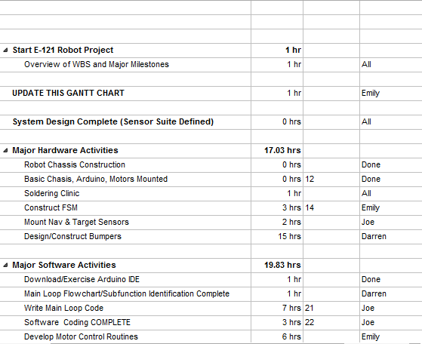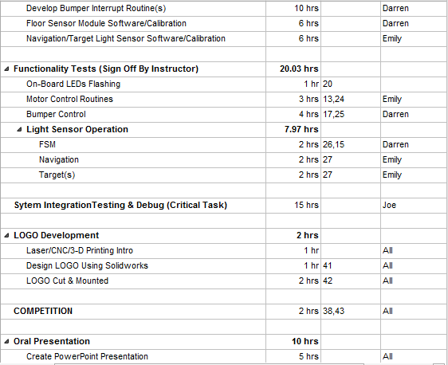 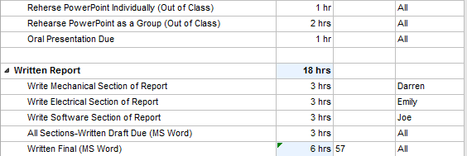

Gantt Chart

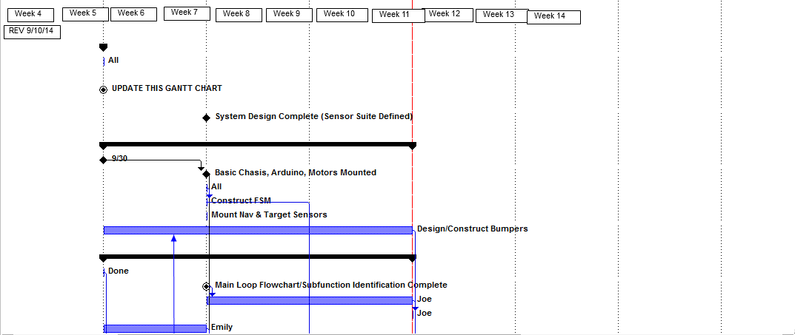

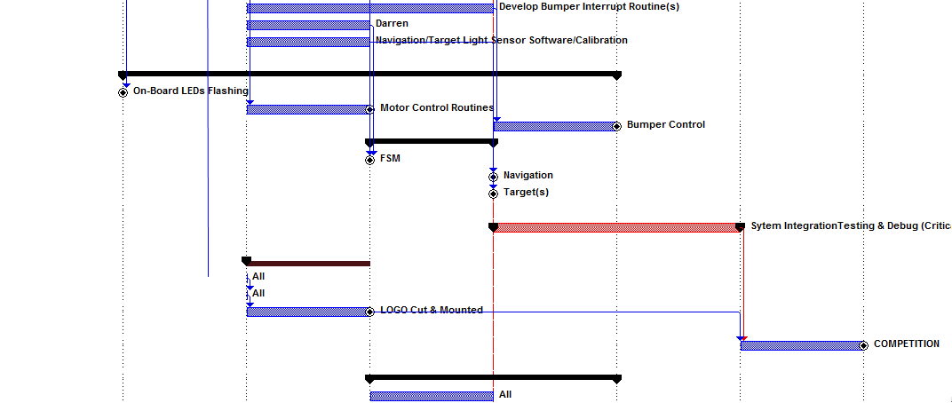

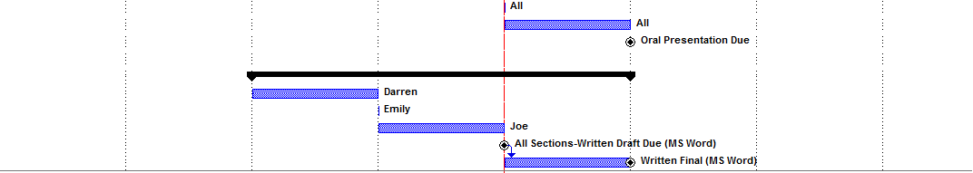

Final Program 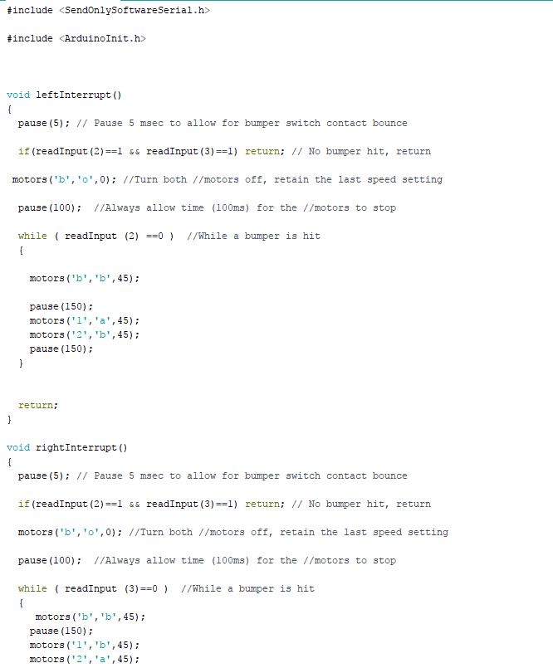

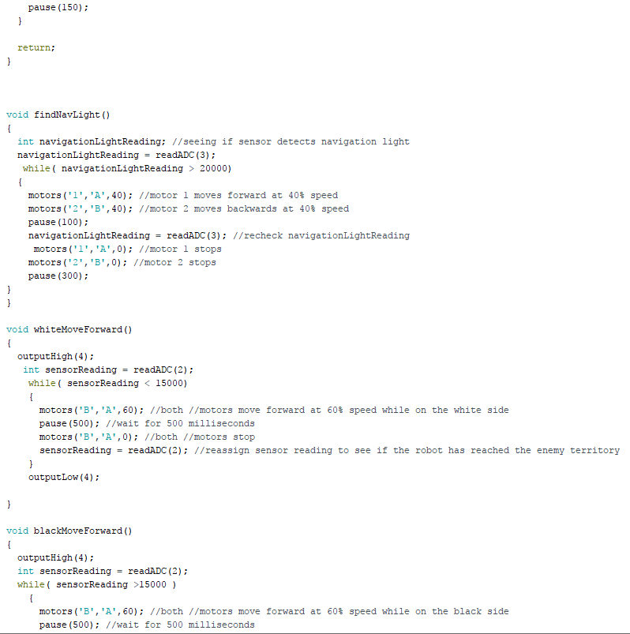

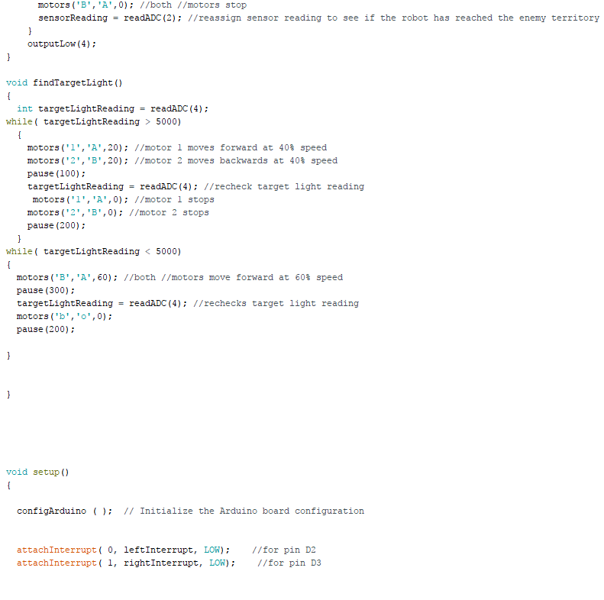

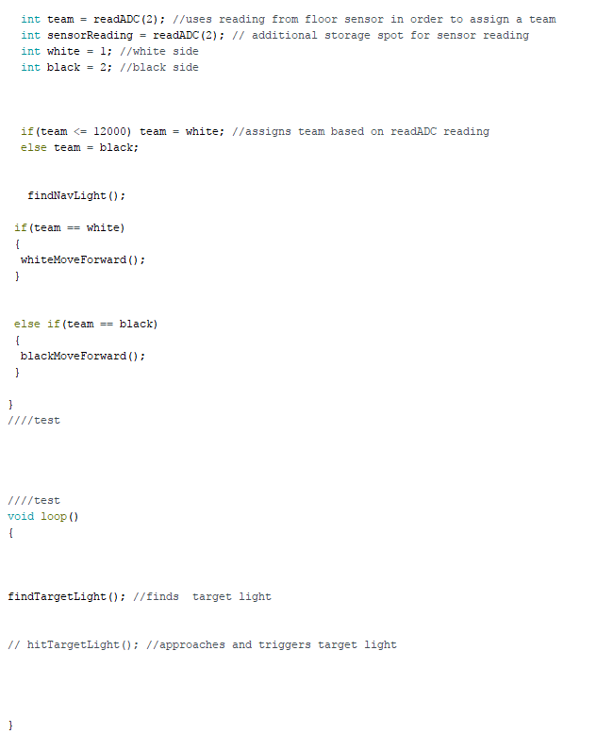

Setup Loop Flowchart

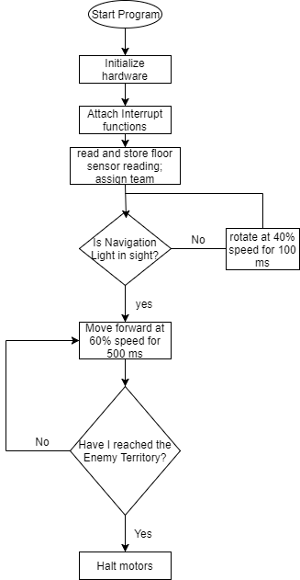

Bumper Interrupt Flowchart

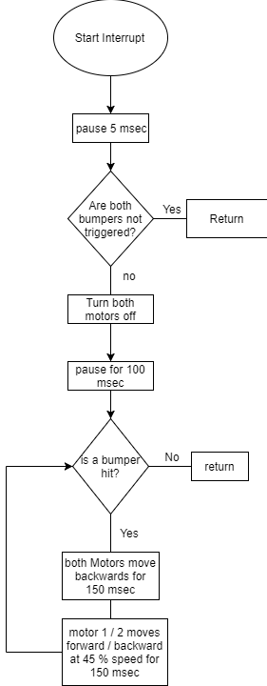

Loop Flowchart

